48.3 Assessment Summary
Tim Earl

Abstract
The following document was submitted to the Stock Assessment Review process to outline the source of current model data and parameters, and to summarise the development of the model. Section 1 summarises the development of the model, this is documented in more detail in Section 18, with a comprehensive reference list of papers related to the development of the model. Sections 2-16 describe the input files used in the most recent (2017) assessment, indicating the source of externally estimated parameters, and the data used in fitting the model. Section 17 outlines the data weighting approach used in fitting the model to multiple sources of data.

48.3 Assessment Summary
Tim Earl

Development history
See detail of all relevant papers at the end of this document for further details
Year | Changes from previous assessment
1985 | Start of catch time series
1997 | Observers on all vessels
2006 | First CASAL assessment (Hillary et al. 2006)
2009 | Catch at age data included. Total catch corrected for depredation
2011 | Inclusion of 0.006377 tag loss factor, depredation corrected CPUE included. Sensitivity testing of 2 vs 3 fleet model
2013 | Investigation of 2 fleet vs 3 fleet representation of catch data. Use of two fleet model was preferred.
2015 | Francis weighting introduced.
2017 | No changes except for two additional years of data

In the associated bundle:
- Input files after Francis weighting
- Output diagnostics
- All papers referred to in this document (FSA-17-53 is the most recent assessment). These are referenced in full in Table 1.
Current assessment:
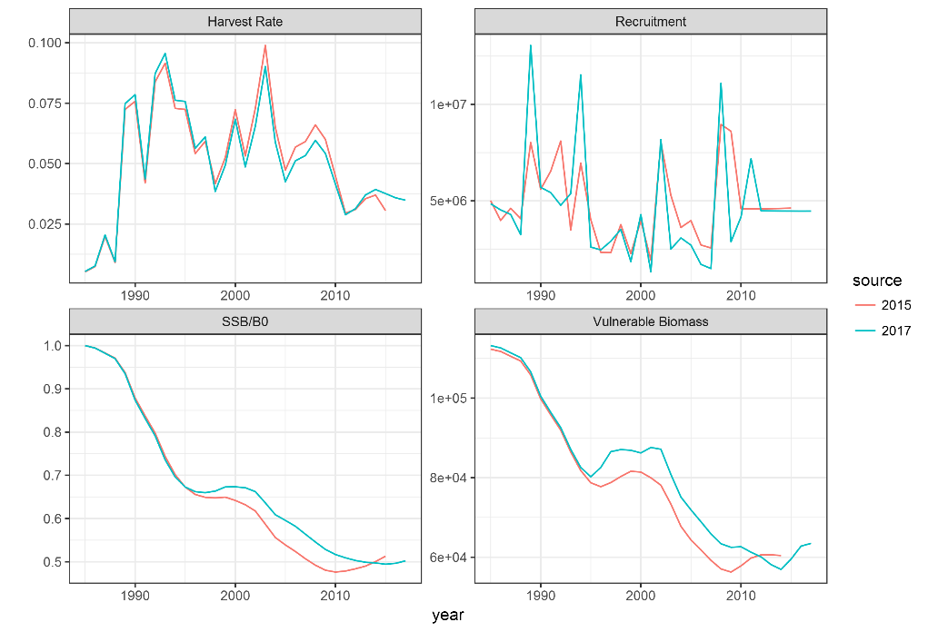
Figure 1: Stock summary MPD runs; Red: Assessment presented at FSA 2015, Turquoise: 2017 assessment using all currently available data.

Model setup

Values
Age range: 1-50+
Year range 1985-present
Single area, single stock with no separate sex/maturity partition
Annual cycle:
- Period 1 (Dec-Feb, 0.25 years) Recruitment
- Period 2 (Mar-Jun, 0.33 years) Spawning_time (partial mortality 0.5), fishery
- Period 3 (Jul-Nov, 0.42 years) Recruitment
- Period 4 (instantaneous) Aging

Model representation
Population.csl
@size_based False
@min_age 1
@max_age 50
@plus_group True
@sex_partition False
@mature_partition False
@n_areas 1
@n_stocks 1
@n_tags 14
@tag_names 2003Tags ... 2016Tags

@initial 1985
@current 2017
@final 2052

@annual_cycle
time_steps 4
recruitment_time 1
spawning_time 2
spawning_part_mort 0.5
spawning_ps 1.0
aging_time 4
M_props 0.4166667 0.3333333 0.25 0.0
growth_props 0.4166667 0.75 1.0 0.0
baranov False
fishery_names FSG1 FSGS2
fishery_times 2 2

@y_enter 1
@n_quant 15

Optimiser settings

Model representation
Estimation.csl
@estimator Bayes
@max_iters 1000
@max_evals 4000
@grad_tol 0.002

@MCMC
start 0
length 1300000
keep 1000
adaptive_stepsize True
adapt_at 100000 200000
burn_in 3000
proposal_t True
df 4

@profile
parameter initialization.B0
n 11
l 40000
u 140000

@q_method nuisance

@ageing_error
type normal
c 0.1

Notes
Profile range changed 2018 to increase range and resolution. Burn in changed to remove the period with stepsize changing.
Burn in increased in 2018 so that it is larger than adaptive stepsize.

Initial biomass

Values
B0 initialised at 70,000 tonnes
Uniform-log prior on 20,000 tonnes to 1,000,000 tonnes

Model representation
Population.csl
@initialization
B0 70000
Estimation.csl
@estimate
parameter initialization.B0
lower_bound 20000
upper_bound 1000000
prior uniform-log
phase 1

Recruitment

Source data/Values
Beverton Holt recruitment form, with initial value of steepness set to 0.75.
Free estimates 1985-(current-7)
Year_range 1992-(current-6)
@randomisation_method lognormal-empirical
Priors bounded on [0.001,20], lognormally distributed with mu=1, cv=0.8, except first year and last 7 which are fixed to 1.
Model relatively insensitive to changes in steepness (Hillary 2006). Earl (2015, unpublished) showed that steepness values 0.4-0.99 (compared to assessment value of 0.75) made only a minor difference to the perception of the stock status. The effect on projections shows that the sustainable catch is reduced by the steepness lower than 0.75, but remains relatively unchanged for higher values.

Model representation
Population.csl
@recruitment
YCS_years 1984 ... 2016
YCS 1 ... 1
SR BH
steepness 0.75
first_free 1985
last_free 2010
year_range 1992 2011

@first_random_year 2008

@randomisation_method lognormal-empirical

@standardise_YCS True
Estimation.csl
@estimate
parameter recruitment.YCS
lower_bound 1 0.001 ... 0.001 1 1 1 1 1 1 1
upper_bound 1 20 ... 20 1 1 1 1 1 1 1
prior lognormal
mu 1 ... 1
cv 0.8 ... 0.8
phase 1

Notes
Since FSA-13 recruitment post 1992 has been used in projections as a more precautionary assumption, given that recruitment has been lower in this period than previously. See also WG-FSA-13 paragraph 4.21 for recruitment in projections.

Maturity ogive

Source data/Values

Model representation
Population.csl
@maturity_props
all allvalues_bounded 1 23 0 0 0 0 0 0.06 0.14 0.22 0.3 0.38 0.46 0.54 0.62 0.658 0.7 0.742 0.784 0.826 0.868 0.91 0.952 0.994 1

Notes
In Hillary et al. 2006 the maturity was given as a length based ogive. In 2011 an age-based ogive was used. The timing and reasoning for this change is not clear, but may be related to the inclusion of catch at age data in 2009.

Natural mortality
Fixed value for all ages

Source data/Values
0.13

Model representation
Population.csl
@natural_mortality
all 0.13

Notes
0.165 in Hillary 2006, but the value of 0.13 dates back to WG-FSA-05/18

Growth

Source data/Values
Length-weight parameters date back to Hillary et al. (2006). Length-weight fitting to the data from different years resulted in little change to the parameter estimates and assessment (Earl, 2015; unpublished).
Von Bertalanffy growth parameters estimated in WG-FSA-11/33-rev-1, and sensitivity testing in Earl (2015; unpublished). The variability between years suggests that the parameters may be poorly estimated, partly due to aging errors, and also affected by changes in sampling (recent seasons have seen samples stratified by length to get a wider spread)
Within the model these parameters affect the fit of early part of the catch composition (no age data, only lengths) and the tag data, where releases and recaptures are measured (obviously hard to age released fish).

Model representation
Population.csl
@size_at_age_type von_Bert

@size_at_age_dist normal

@size_at_age
k 0.08
t0 -0.7
Linf 126
cv 0.08

@size_weight
a 2.54e-8
b 2.8
verify_size_weight 150 30 50

Notes
Growth estimated externally in 48.3, internally in 48.4

Tagging release data
Tagging data is available from 2003 release cohort onwards. Release mortality is estimated externally using a length dependent relationship:
Length class (cm) | 30, 40 | 50 | 60 | 70 | 80 | 90 | 100+
Survival | 0 | 0.96 | 0.95 | 0.95 | 0.94 | 0.83 | 0.80
Within the model, no further post-release tagging occurs.
All releases since 2003 are included where the fish length is in the range [30,200) cm, the release area is 48.3 and the release species is recorded as “TOP”.

Source data/Values
Tag shedding rate 0.006377 based on linear approximation over four years to the observed double tag loss rate.
There is a 0.75 year no growth period – WG-FSA-07/29

Model representation
Population.csl
@tag_shedding_rate 0.006377 0.006377 0.006377 0.006377 0.006377 0.006377 0.006377 0.006377 0.006377 0.006377 0.006377 0.006377 0.006377 0.006377

@tag_loss_props 0.4166667 0.3333333 0.25 0.0

@tag_growth_loss 2003Tags
nogrowth_period 0.75
...
@tag_growth_loss 2016Tags
nogrowth_period 0.75

@tag 2003Tags
...
@tag 2016Tags
tag_name 2016Tags
release_type deterministic
sex both
year 2016
step 2
mature_only False
number <Number released corrected for in-year recaptures and instant mortality>
plus_group False
class_mins 40 50 60 70 80 90 100 110 120 130 140
props_all <Proportions at length>
mortality 0.
ogive SelSGS2

Notes
Instant tag mortality is estimated externally, based on a length-dependent relationship, and so no further tag mortality is applied in the model.

References
Tag mortality at length described in WG-FSA-07/29
Effect of double tagging: WG-SAM-11/16 and WG-SAM-11/12 leading to tag loss rate estimate
WG-SAM-09/13: Adding catch at age and survey data to the 48.3 toothfish CASAL assessment.

Tag recaptures

Source data/Values

Processing
Tags are matched and included as recaptures based on the following criteria:
- At least one of the release tags matches at least one of the tags recorded at recapture
- Both recapture and release species are “TOP”
- The tag was released and recaptured in 483
- The recapture season is after the release season (in year recaptures are deducted from the releases), and within 4 years
- Recapture length between 60 and 120cm
- Release length between 40 and 150cm

Model representation
Estimation.csl
@tag_recapture 2003Tags
...
@tag_recapture 2016Tags
tag_name 2016Tags
sample size
detection_probability 1
years 2017
step 2
proportion_mortality 1.0
plus_group True
class_mins 60 70 80 90 100 110
recaptured_2017 1 14 61 78 20 4
scanned_2017 4373.39 36605.95 89630.76 77711.21 31043.21 10148.01
do_bootstrap True
r 1e-11
dispersion 8.681729

@fish_tagged_penalty
label 2003TagPenalty
tagging_episode 2003Tags
multiplier 1
...
@fish_tagged_penalty
label 2016TagPenalty
tagging_episode 2016Tags
multiplier 1

Notes
Recapture data is from 2006-present. For each tagging cohort, the four following years recaptures are included. Scanned numbers based on raised numbers at length.
Dispersion factor calculated in WG-FSA-11/33-rev-1, recalculated as part of the Francis weighting

References
WG-SAM-17/35 looking at tag recapture duration

Catches
The catch is split into two sections based on the availability of age data
Pot data not included as it is insignificant
Future catches (for 35 years based on the CCAMLR harvest control rule)

Source data/Values

Processing
Catches from 2004 to present are corrected for mammal observation using a GLM with factors nationality, year, month, depth band, area and cetacean presence. The correction factor is the difference between predictions with and without cetaceans, multiplied by the proportion of lines on which cetaceans are observed.
Early catch doesn’t quite match with Hillary 2006

Scripts

1_CPUE_SG3 inputs.r

Assumptions

Model representation
Population.csl
@fishery FSG1
years 1985 1986 1987 1988 1989 1990 1991 1992 1993 1994 1995 1996 1997
catches 517 732 1954 876 6962 6828 3554.511116 6909.703852 7085.869088 5279.923763 5020.649006 3606.633227 3888.146453
U_max 0.99999
selectivity SelSG1

@fishery FSGS2
#After correction for depredation since 2004
years 1998 1999 2000 2001 2002 2003 2004 2005 2006 2007 2008 2009 2010 2011 2012 2013 2014 2015 2016 2017
catches 3409.777963 4386.914453 6087.082453 4357.774257 5887.269594 7615.662 <Values from 2004 onwards change each year>

future_years 2018 2019 2020 2021 2022 2023 2024 2025 2026 2027 2028 2029 2030 2031 2032 2033 2034 2035 2036 2037 2038 2039 2040 2041 2042 2043 2044 2045 2046 2047 2048 2049 2050 2051 2052
future_catches <Constant value to achieve CCAMLR objectives>
Estimation.csl
@catch_limit_penalty
label catch_limit
log_scale False
fishery FSG1
multiplier 100

@catch_limit_penalty
label catch_limit
log_scale False
fishery FSGS2
multiplier 100

Catch composition
The catch is split into two sections based on the availability of age data, For 1988-1997 catch is broken down into 10cm length bins (40-230). Since 1998, the observed length distribution is raised to an age distribution using a year-specific age length relationship based on around 200-300 otoliths.

Visualisation
The standardised proportions at age show that there are is some internal consistency within the aging, but the strong cohorts are not always linear, suggesting that there is some aging error. Consecutive cohorts seem to be well correlated, suggesting that either there is autocorrelation in recruitment, or that the error in aging is causing a smudging of the cohorts.
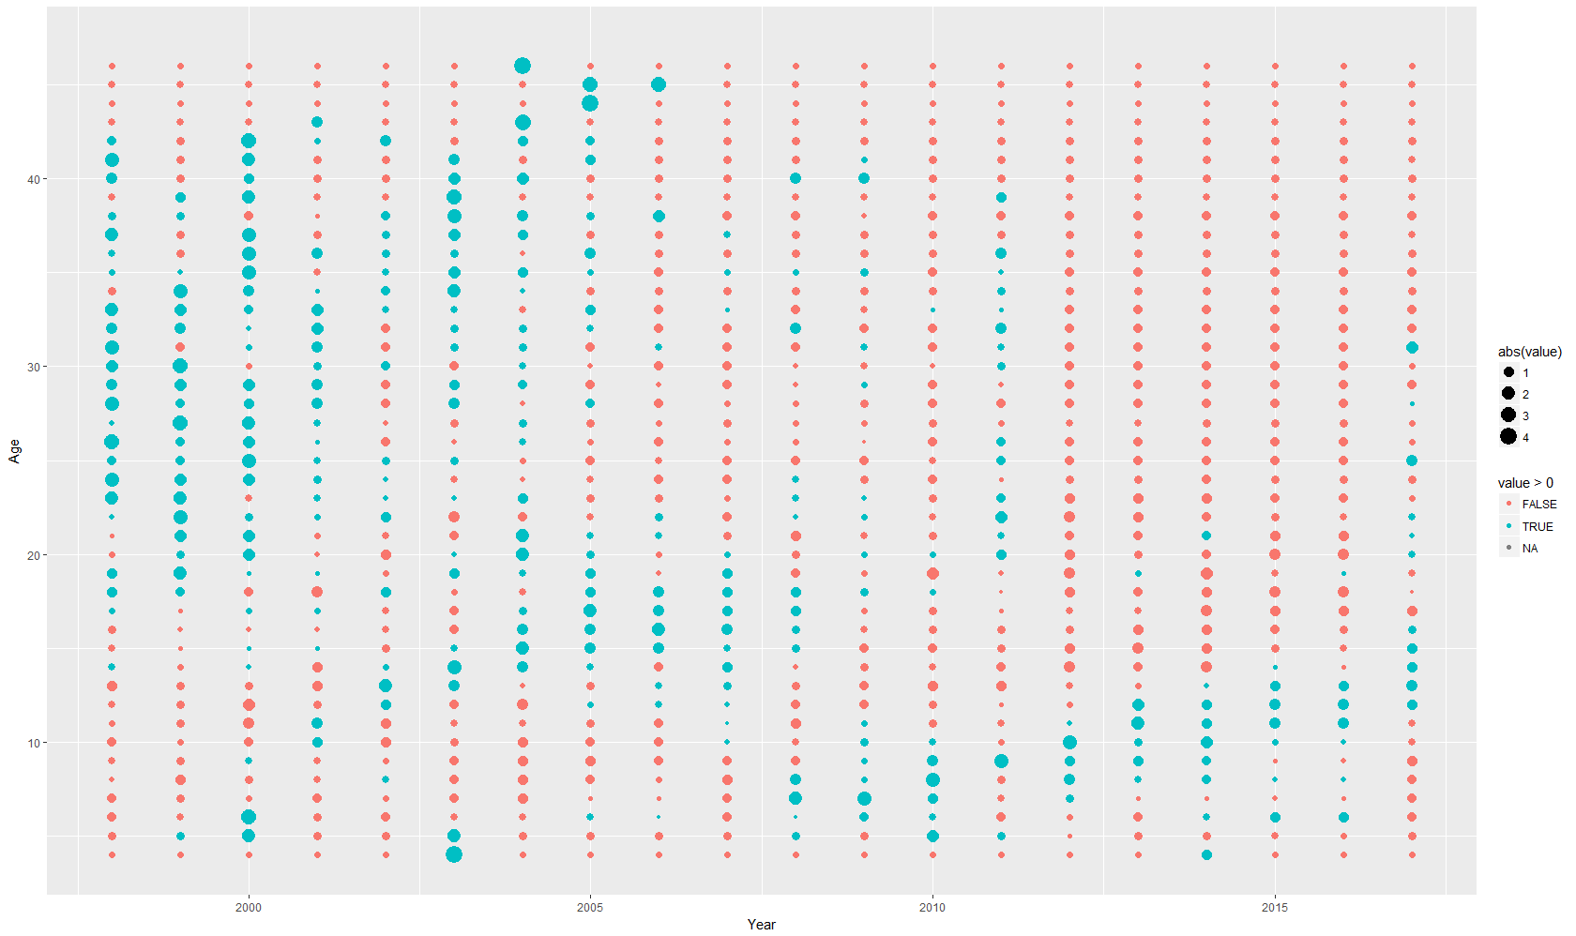
Figure 1: Standardised proportions at age (mean and standard deviation of each age equal)

Model representation
Population.csl
@selectivity_names SelSG1 SelSGS2 SelSurvey

@selectivity SelSG1
all double_normal 12 2.95 14.22

@selectivity SelSGS2
all double_normal 8.63 1.17 9.79
Estimation.csl
@catch_at FSG1Catch
years 1988 ... 1997
fishery FSG1
at_size True
sexed False
sum_to_one True
plus_group False
class_mins 40 ... 230
1988 <Proportions at age data>
...
1997
dist multinomial

N_1988 <Number of otoliths read>
...
N_1997

r 1e-11

#1998-2002 historic data,
#2003-2014 CCAMLR data with catch correction for depredation
#2015 TRAFISH data with catch correction for depredation
@catch_at FSGS2Catch
years 1998 ... 2017
fishery FSGS2
at_size False
sexed False
sum_to_one True
plus_group False
min_class 4
max_class 47
1998 <Proportions at age data>
...
2017

dist multinomial
r 1e-11

#Sample sizes initially set to the number of otoliths aged
N_1998 <Number of otoliths read>
...
N_2017

@estimate
parameter selectivity[SelSG1].all
lower_bound 1 0.05 0.05
upper_bound 50 50 500
prior uniform
phase 1

@estimate
parameter selectivity[SelSGS2].all
lower_bound 1 0.05 0.05
upper_bound 50 50 500
prior uniform
phase 1

Notes
Catch sampling for otoliths has varied in recent years between random sampling and stratified sampling. This results in differences between years in the von Bertalanffy parameters.
Both catch selectivities end up being estimated as very close to flat-topped, so no obvious problem with a cryptic biomass sustaining the stock.

CPUE

Source data/Values

Processing
A GLM with factors nationality, year, month, depth band, area and cetacean presence is applied to data since 2003. A standardised prediction is made for years 2004-present to give the CPUE index and cv. CPUE from 1998-2003 is not updated each year.

Model representation
Estimation.csl
@relative_abundance CPUESG2
biomass True
q CPUESG2q
years 1998 1999 2000 2001 2002 2003
step 2
ogive SelSGS2
proportion_mortality 0.5

1998 291.357
1999 353.9203
2000 404.16
2001 364.5833
2002 367.8804
2003 437.5982

cv_1998 0.029465484
cv_1999 0.026152357
cv_2000 0.021927764
cv_2001 0.023762882
cv_2002 0.021481778
cv_2003 0.015567477
dist lognormal
cv_process_error .05

@estimate
parameter relative_abundance[CPUESG2].cv_process_error
lower_bound 0.001
upper_bound 5
prior uniform
phase 1
MCMC_fixed true

@estimate
parameter q[CPUESG2q].q
lower_bound 1e-8
upper_bound 1e-1
prior uniform-log
phase 1

@relative_abundance CPUESG3
biomass True
q CPUESG3q
years 2004 2005 2006 2007 2008 2009 2010 2011 2012 2013 2014 2015 2016 2017
step 2
ogive SelSGS2
proportion_mortality 0.5

2004 <Varies each year>
…
2017

cv_2004 <Varies each year>
…
cv_2017

dist lognormal
cv_process_error .05

@estimate
parameter relative_abundance[CPUESG3].cv_process_error
lower_bound 0.001
upper_bound 5
prior uniform
phase 1
MCMC_fixed true

@estimate
parameter q[CPUESG3q].q
lower_bound 1e-8
upper_bound 1e-1
prior uniform-log
phase 1

References
WG-FSA-10/P06 describes the standardisation of the CPUE.

Survey
Primarily for icefish, the survey produces an index of recruitment around Shag Rocks.

Model representation
Estimation.csl
@relative_abundance Survey
years 1987 1988 1990 1991 1992 1994 2000 2002 2004 2005 2006 2007 2008 2009 2010 2011 2012 2013 2015 2017
step 1
proportion_mortality 0.5
q Surveyq
biomass True
ogive SelSurvey

1987 301.7713067
1988 727.2887557
1990 1752 # 5142.626012
1991 771.5069343
1992 1379.788214
1994 1467.5197
2000 502.4634315
2002 758.1715134
2004 323.2983502
2005 410.1716331
2006 392.9253769
2007 15.39489011
2008 79.79823064
2009 61.88936806
2010 137.0508893
2011 2633.338326
2012 105.9
2013 218.1
2015 119.209
2017 21.132

cvs_1987 0.302372117
cvs_1988 0.68030303
cvs_1990 0.490 # 0.56679868
cvs_1991 0.353267579
cvs_1992 0.359258936
cvs_1994 0.50560166
cvs_2000 0.451717902
cvs_2002 0.361572376
cvs_2004 0.4066967
cvs_2005 0.351062012
cvs_2006 0.392693142
cvs_2007 0.577856184
cvs_2008 0.433094592
cvs_2009 0.548667745
cvs_2010 0.284156803
cvs_2011 0.7712253
cvs_2012 0.380
cvs_2013 0.713
cvs_2015 0.472672
cvs_2017 0.582

dist normal
cv_process_error 0.5

@estimate
parameter relative_abundance[Survey].cv_process_error
lower_bound 0.001
upper_bound 5
prior uniform
phase 1
MCMC_fixed true

@estimate
parameter q[Surveyq].q
lower_bound 1e-8
upper_bound 1e-1
prior uniform-log
phase 1

References
Survey reports are listed in Table 1, e.g. WG-FSA-17/44

Survey length composition
The samples are not currently aged routinely, but sensitivities using aged compositions where available showed similarly poor fit to the model.

Model representation
Population.csl
@selectivity SelSurvey
all double_normal 2 1.17 9.79
Estimation.csl
@proportions_at SurveyLength
years 1987 1988 1990 1991 1992 1994 2000 2002 2004 2005 2006 2007 2008 2010 2011 2012 2013 2015 2017
step 1
proportion_mortality 1.0
at_size True
sexed False
sum_to_one True
plus_group False
ogive SelSurvey
class_mins 10 15 ... 75

1987 <Proportions by length class and year>
...
2017

N_1987 <Number of hauls in Shag Rocks>
...
N_2017

dist multinomial
r 0.00001

@estimate
parameter selectivity[SelSurvey].all
lower_bound 1 0.05 0.05
upper_bound 30 40 500
prior uniform
phase 1

References
Survey reports are listed in Table 1, e.g. WG-FSA-17/44

Model Output

Source data/Values

Processing

Scripts

Assumptions

Model representation
Output.csl
@print
parameters false
fits_every_eval false
objective_every_eval false
parameters_every_eval false
parameter_vector_every_eval false
fits true
resids true
pearson_resids true
normalised_resids true
estimation_section true
requests false
initial_state false
state_annually t
state_every_step true
final_state true
results false
yields true
unused_parameters true
covariance True

@quantities
all_free_parameters true
fishing_pressures true
nuisance_qs true
B0 true
R0 true
SSBs true
recruitments true
YCS true
true_YCS true
actual_catches false
ogive_parameters selectivity[SelSG1].all selectivity[SelSGS2].all #selectivity[SelSGSD].all
fits true
normalised_resids false
tagged_age_distribution true

@print_sizebased_ogives_at 10 15 ... 220

@selectivity_at SelSG1-at-age
ogive SelSG1
years 2000
step 2
proportion_mortality 0.5
sexed False

@selectivity_at SelSGS2-at-age
ogive SelSGS2
years 2000
step 2
proportion_mortality 0.5
sexed False

@abundance vulnerable
biomass true
mature_only false
step 2
proportion_mortality 0.5
ogive SelSGS2
years 1985 ... 2017

Data weighting
The data weighting is an iterative process. Initially the following weights are assigned to the data sources:
- Catch CPUE: Estimated cv, process error = 0.05
- Catch length distribution 1988-1997: Historic values for sample size, r=1e-11
- Catch age distribution 1998-present: Number of otoliths aged, r=1e-11
- Survey abundance: estimated CV, process error = 0.5
- Survey proportions at length: Number of hauls in Shag Rocks, multinomial r=0.00001
- Aging error: c=0.1
- Tag recaptures: r=1e-11, dispersion=8.681729
The weighting steps are as follows:
- The model is run with the default weightings
- The effective sample size of the catch proportions at age and length is scaled according to method TA1.8 from the R dataweighting package. Process errors for catch and survey compositions are constrained to be small (less than 0.002) and the model is rerun.
- The effective sample size of the catch proportions at age and length is scaled according to method TA1.8 from the R dataweighting package and the model is rerun.
- Tag dispersion is rescaled according to the method Reweight.tags in the dataweighting package.
- Process errors for catch and survey compositions are freed up to be estimated and the model is rerun

Papers used in the development of the assessment
Table 1: Papers relevant to the assessment of Toothfish in 48.3
Meeting | Paper summary
FSA-17 | WG-FSA-17/44 Report of the UK groundfish survey at South Georgia (CCAMLR Subarea 48.3) in January 2017. M. Belchier, V. Foster, S. Gregory, S. Hill, V. Laptikhovsky, P. Lafite and L. Featherstone  Icefish survey report used to provide index of TOP recruitment  WG-FSA-17/53 Assessment of Patagonian toothfish (D. eleginoides) in Subarea 48.3. T. Earl and S. Fischer  Update of assessment using partial data from 2016/17 season.  WG-FSA-17  3.20 Recommends to only use complete seasons of data that have been quality checked by the CCAMLR secretariat in future.  3.21 Recommends fitting survey as biomass and proportions in composition (Already done)  3.26 Look at additional work to identify the source of successively decreasing estimates of SSB₀ between assessments.
SAM-17 | WG-SAM-17/35 Sensitivities in the assessment of the Patagonian toothfish (D. eleginoides) in Subareas 48.3 and 48.4 to truncation of tagging data. T. Earl  Looking at the effect of including different numbers of years post release in the assessment. No change to 48.3 (48.4 reduced from 6 to 4 years for consistency). There is some outstanding bias in the tag recaptures not explained by the double-tagging effect.  WG-SAM-17  2.12 Recommendation to re-estimate the tag loss and instantaneous mortality using the most up to date data. Reduce years if tagging to four to reduce bias from double-tagging.
FSA-16 | NA
SAM-16 | NA
FSA-15 | WG-FSA-15/30 Report of the UK groundfish survey at South Georgia (CCAMLR Subarea 48.3) in January 2015. M. Belchier, S. Gregory, N. Fallon, J. McKenna, S. Hill, M. Soffker (United Kingdom), P. Lafite (South Africa) and L. Featherstone (United Kingdom)  Icefish survey report used to provide index of TOP recruitment  WG-FSA-15/59 Assessment of the Patagonian Toothfish (D. eleginoides) in Subarea 48.3. T. Earl, M. Soeffker and C. Darby (United Kingdom)  Update of assessment  WG-FSA-15  4.34 Investigate sources of mis-fitting to age composition and survey index  4.36 Evaluate the effect of alternative data weighting approaches  4.117(i)-(vii) Areas to develop stock assessments
SAM-15 | WG-SAM-15/29 Fishery selection for Patagonian toothfish in CCAMLR Subarea 48.3, asymptotic or dome shaped? C. Darby, V. Laptikhovsky and M. Soeffker (United Kingdom)  Dome shaped selectivity unlikely  WG-SAM-15/30 A potential link between the D. eleginoides stocks of Statistical Subareas 48.3 and 48.4. M. Soeffker, M. Belchier and V. Laptikhovsky (United Kingdom)  Tags between 48.4 and 48.3 (mostly males moving to SG and females to SR) Lack of older and younger fish in 48.4 and different growth curves.  WG-SAM-15  2.23 Recommendation to document choice of priors
Other 2015 | Sensitivity testing for Patagonian toothfish in Subarea 48.3 (Earl 2015, unpublished)  Investigating the impact of uncertainty in length-weight relationship, recruitment steepness and age-length relationship on the assessment estimates of historic stock development.  - The length-weight relationships were estimated consistently, and so only a minor change to the assessment was observed by using values from different years.  - Steepness in the range 0.4-0.99 had little impact on the stock development  - The age-length relationships were estimated based on data from each year 1998-present. Using each of these estimates as the input parameters for the assessment resulted in a wide range of stock development, the current assumed values are at the extreme end of the range leading to higher biomasses and lower exploitation rate.
FSA-14 | WG-FSA-14/49 Nine years of tag-recapture in CCAMLR Statistical Subarea 48.3 – Part II: Spatial movement and analysis. M. Soeffker, C. Darby and R.D. Scott (United Kingdom)  Looking at maturity of females, and distances travelled by tagged fish between release and recapture
SAM-14 | WG-SAM-14/35 Nine years of tag-recapture in CCAMLR Statistical Subarea 48.3 – Part I: General data characterisation and analysis. M. Soeffker, C. Darby and R.D. Scott (United Kingdom)  Tag overlap, and growth impairment effect by vessel  WG-SAM-14  2.29 CASAL version 2.30-2012-03-21 rev 4648 be considered the current approved CCAMLR version
FSA-13 | WG-FSA-13/17 Report of the 2013 UK South Georgia Groundfish Survey (CCAMLR Subarea 48.3)  M. Belchier, S. Gregory, K. Brigden, D. Johnston, N. Fallon and L. Featherstone (United Kingdom)  Icefish survey report used to provide index of TOP recruitment  WG-FSA-13/29 A brief characterisation of Patagonian toothfish tag survival and tag detection in CCAMLR Statistical Area 48.3. M. Soeffker and R. Scott (United Kingdom)  Tag loss rate from double tagging and tag detection by vessel  WG-FSA-13/30 Preliminary assessment of Patagonian toothfish in Subarea 48.3  R. Scott (United Kingdom)  Update of assessment  Investigation of splitting catch time series into 2 vs 3 periods  WG-FSA-13  4.18 Re-estimate survey process error, and age survey  4.19 Recommended using 2-fleet model  4.21 Use average recruitment and CV from 1992-2006 for projections  4.93 MPD B0 estimates are validated by the secretariat rerunning assessment.  4.96 Differences in B0 from different versions of CASAL not explained
SAM-13 | NA
FSA-12 | WG-FSA-12/37 Results from the reduced groundfish survey conducted in CCAMLR Subarea 48.3 in January 2012. J. Brown, S. Gregory, A. Stanworth, V. Carretero, G. Baker and M. Belchier (United Kingdom)  Icefish survey report used to provide index of TOP recruitment
SAM-12 | WG-SAM-12/19 Movement of Patagonian toothfish (Dissostichus eleginoides) in Subarea 48.3. T. Peatman, S.M. Martin, J. Pearce and R.E. Mitchell (United Kingdom)  Movement rates low, around 30km/yr
FSA-11 | WG-FSA-11/29 Results from the groundfish survey conducted in CCAMLR Subarea 48.3 in January/February 2011. J. Brown, S. Gregory, K. Brigden, R. Benedet, O. Hogg, P. Brewin and L. Featherstone (United Kingdom)  Icefish survey report used to provide index of TOP recruitment  WG-FSA-11/33 Rev. 1 Preliminary assessment of toothfish in Subarea 48.3. T. Peatman, R.E. Mitchell, G. Parkes and D.J. Agnew (United Kingdom)  Derivation of 0.006377 tag loss factor  Depredation correction of CPUE included  Discussion of 2 vs 3 fleet model  WG-FSA-11  4.19 Concern about poor fit to recruitment survey, but current weighting approach is appropriate  6.17 Removal of historic data should be accompanied by justification and assessment of impact
SAM-11 | WG-SAM-11/12 Models of tag shedding for double tagging as a function of time at liberty and approximate solutions for the single tagging model in CASAL. S.G. Candy (Australia)  WG-SAM-11/18 Estimates of the tag loss rates for single and double tagged toothfish (Dissostichus mawsoni) fishery in the Ross Sea. A. Dunn, M.H. Smith (New Zealand), D.J. Agnew (UK) and S. Mormede (New Zealand)  Discussion of double tagging effect, and its application to the Ross Sea fishery
FSA-10 | WG-FSA-10/38 Results of the groundfish survey carried out in CCAMLR Subarea 48.3 in January 2010. R.E. Mitchell, M. Belchier, S. Gregory, L. Kenny, J. Nelson, J. Brown and L. Feathersone (UK)  Icefish survey report used to provide index of TOP recruitment  WG-FSA-10/P05 The Patagonian toothfish: biology, ecology and fishery. M.A. Collins, P. Brickle, J. Brown and M. Belchier  Everything about Toothfish  WG-FSA-10/P06 Estimating the impact of depredation by killer whales and sperm whales on longline fishing for toothfish (Dissostichus eleginoides) around South Georgia. J. Moir Clark and D.J. Agnew  Background to the depredation model used to estimate total fisheries removal and CPUE.  WG-FSA-10/35 Results of the research fishing activities conducted by Chile in Management A of Subarea 48.3 from 2005–2008: the importance of conserving the big older fishes. C.A. Moreno and P. Rubilar (Chile)  Summary of CPUE and catch characteristics of catch in 48.3A
SAM-10 | WG-SAM-10/11 Rev. 1 Estimation of natural mortality using catch-at-age and aged mark-recapture data: a simulation study comparing estimation for a model based on the Baranov equations versus a new mortality equation. S.G. Candy (Australia)  Simulation testing estimation of M  WG-SAM-10  Discussion of estimates of M
FSA-09 | WG-FSA-09/09 REPORT OF THE UK GROUNDFISH SURVEY AT SOUTH GEORGIA (CCAMLR SUB-AREA 48.3) IN JANUARY 2009  M. Belchier, R.E. Mitchell, M.A. Collins, L. Kenny, M. Taylor, J. Nelson and L. Featherstone (United Kingdom)  Icefish survey report used to provide index of TOP recruitment  WG-FSA-09/16 DEPREDATION AROUND SOUTH GEORGIA AND THE IMPLICATIONS ON STOCK ASSESSMENT OF D. ELEGINOIDES. J. Moir Clark, D.A. Agnew, P. McCarthy and M. Unwin (United Kingdom)  Origin of catch correction model  WG-FSA-09/22 Rev. 1 COMPARISON OF THE PRECISION OF DIRECT VERSUS AGE LENGTH KEY METHODS OF ESTIMATING CATCH-AT-AGE PROPORTIONS  S.G. Candy (Australia)  Sampling ages based on length binned samples rather than unbinned samples  WG-FSA-09/28 Rev. 1 PRELIMINARY ASSESSMENT OF TOOTHFISH IN SUBAREA 48.3. D.J. Agnew and T. Peatman (United Kingdom)  Tag data 2000-2009 included in paper (only 2003 onwards used in assessment)  Inclusion of survey data (1999-2008)  Change to catch at age from catch at length
SAM-09 | WG-SAM-09/13 ADDING CATCH AT AGE AND SURVEY DATA TO THE 48.3 TOOTHFISH CASAL ASSESSMENT  D.J. Agnew and M. Belchier (United Kingdom)  Investigating the suggestions from FSA-07  Growth parameters estimated within model?  investigate sex disaggregation  3.5 Incorporating survey data into assessment – exclude September surveys, use length frequencies for all available surveys.
FSA-08 | WG-FSA-08/28 GROUNDFISH SURVEY IN CCAMLR SUB-AREA 48.3 IN APRIL 2008 WITH PRELIMINARY ASSESSMENT OF MACKEREL ICEFISH  M.A. Collins, R.E. Mitchell, C.E. Main, J. Lawson, J. Watts, J. Slakowski, L. Featherstone and O. Rzewuski (UK)  Icefish survey report used to provide index of TOP recruitment
SAM-08 | NA
FSA-07 | WG-FSA-07/29 Preliminary assessment of the South Georgia toothfish stock, 2007. D.J. Agnew, R. Hillary and J. Pearce (United Kingdom)  WG-FSA-07  Report: Investigate issues including use of catch-at-age and tag recapture at length bias in 48.3 assessment.
SAM-07 | WG-SAM-07/13 An assessment strategy evaluation framework for testing the application of a CASAL based management system to the HIMI fishery  I.R. Ball and S.G. Candy (Australia)  WG-SAM-07/7 Comparison of estimators of effective sample size for catch-at-age and catch-at-length data using simulated data from the Dirichlet-multinomial Distribution  S.G. Candy (Australia)  Method of calculating sample size
FSA-06 | WG-FSA-06/51 Report of the South Georgia groundfish survey (Subarea 48.3) in January 2006. M.A. Collins, C. Jones, J. Clark. S. Fielding, J. Slakowski, T. North, W. Reid and J. Watts (United Kingdom)  Icefish survey report used to provide index of TOP recruitment  WG-FSA-06/53 Assessment of toothfish in Subarea 48.3, 2006  D.J. Agnew, R. Hillary, M. Belchier, J. Clark and J. Pearce (United Kingdom)  WG-FSA-06/54 Estimates of natural and fishing mortality from toothfish mark–recapture and catch-at-age data at South Georgia  R.M. Hillary and D.J. Agnew (United Kingdom)  WG-FSA-06/59 A proposal methodology to assess the Patagonian toothfish stock abundance at CCAMLR Subarea 48.3 using ASPM  O.C. Wöhler and P.A. Martínez (Argentina)
FSA-SAM-06 | WG-FSA-SAM-06/06 Using mark-recapture and catch-age data to estimate fishing and natural mortality for the Patagonian toothfish at South Georgia. R.M. Hillary and D.J. Agnew (United Kingdom)  WG-FSA-SAM-06/13 Review of some assumptions for modelling Patagonian toothfish dynamics at CCAMLR Subarea 48.3  A. Aubone, P.A. Martínez and O.C. Wöhler (Argentina)
Other 2006 | Hillary, R.M., G.P. Kirkwood and D.J. Agnew (2006), An assessment of toothfish in Subarea 48.3 using CASAL. CCAMLR Science  Description of the first CASAL assessment for 48.3.  - Tag loss rate: 0.0036y⁻¹  - Initial Tag mortality: 10%  - Growth retardation period: 6 months  - M: 0.165  - Maturity at length parameterisation  - External estimates of sample size for catch proportions at length, CPUE CV followed by an iterative reweighting for one step.  Sensitivities:  - Including survey estimates of young fish  - Two fleets for catch vs one  - Varying M  - Varying h (stock recruit steepness)  - Alternate growth models  - Removing CPUE  - Removing tagging data  - Removal of tagging cohorts
FSA-05 | WG-FSA-05/18 Parameters for the assessment of toothfish in Subarea 48.3. D.J. Agnew, G.P. Kirkwood, A. Payne, J. Pearce and J. Clarke (United Kingdom)  Beverton-Holt invariants presented  WG-FSA-05  4.18 Discussion about recruitment uncertainty in projections

Throughout this document the data included is that which was available at the end of the 2016/17 fishing season, i.e. the extent of the data is the same as for the assessment presented at WG-FSA-17.

