Figure 1. Net diagram “Komandor”
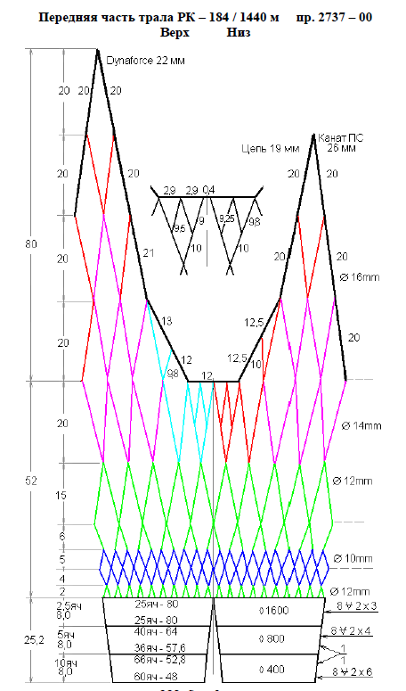

Figure 2. Net diagram “Komandor”
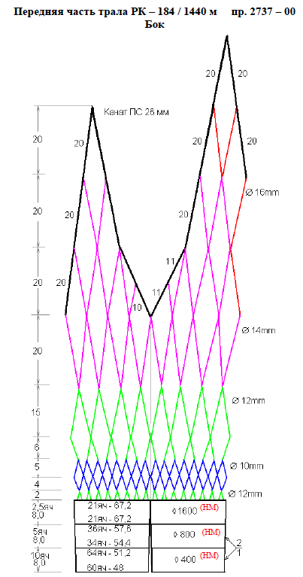

Figure 3. Net diagram “Komandor”
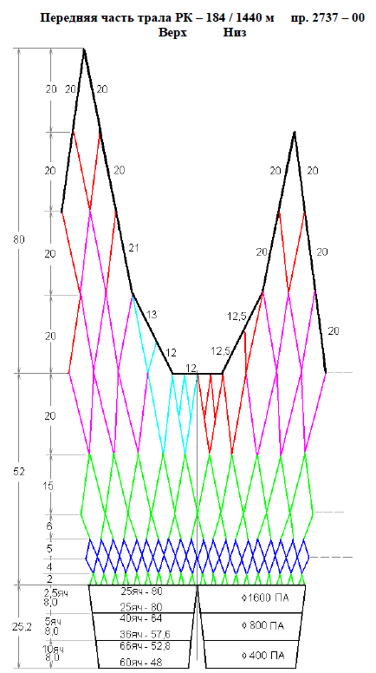

Figure 4. Net diagram “Komandor”
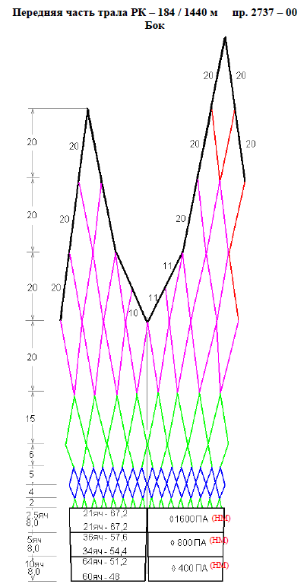

Figure 5. Net diagram “Komandor”
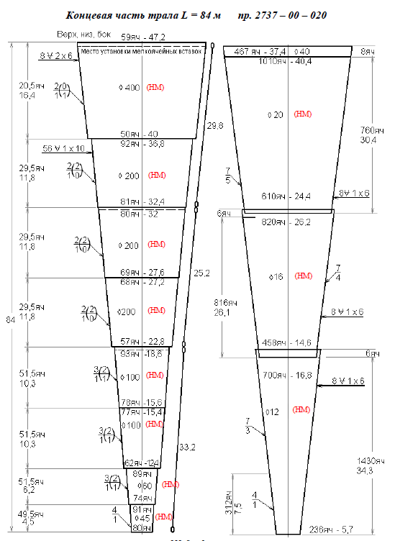

Figure 6. Net diagram “Komandor”
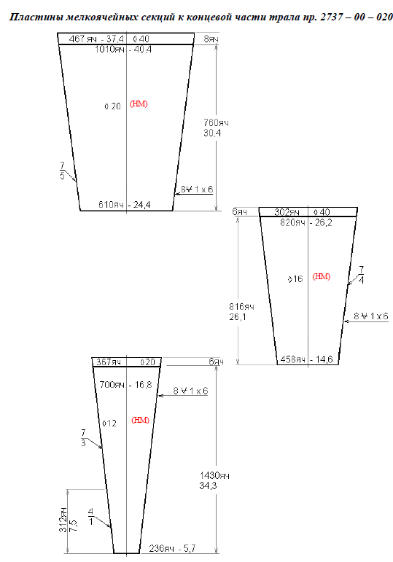

Figure 7. Net diagram “Komandor”

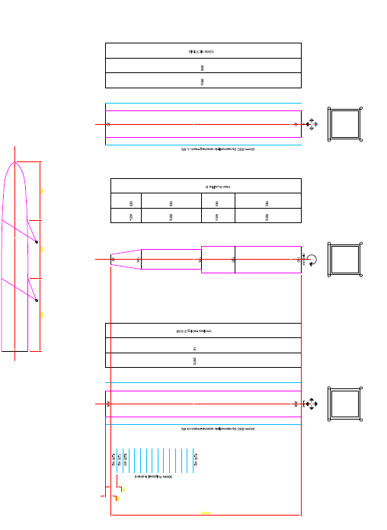

Figure 8. Marine mammal exclusion device “Komandor”

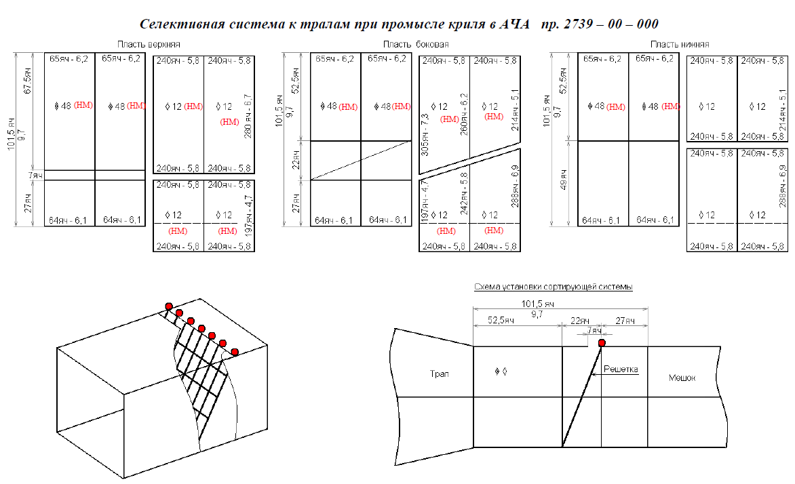
Opening size: 672 x 6144 mm.
Grid mesh size before codend: 100 mm.

