

Marine mammal exclusion device

Device diagram(s): KWANG JA HO

For each type of device used, or any change in device configuration, refer to the relevant diagram in the CCAMLR fishing gear library if available ( www.ccamlr.org/node/74407), or submit a detailed diagram and description to the forthcoming meeting of WG-EMM.

- Uses of marine mammal protect net: We use this device to prevent sea lions from capturing. Sea lions can escape through the square hole whose size is 1.5m and located on the top of the net, when they enter into the net by accident. This device is very effective, but sea lions were sometimes captured only in the South Georgia.
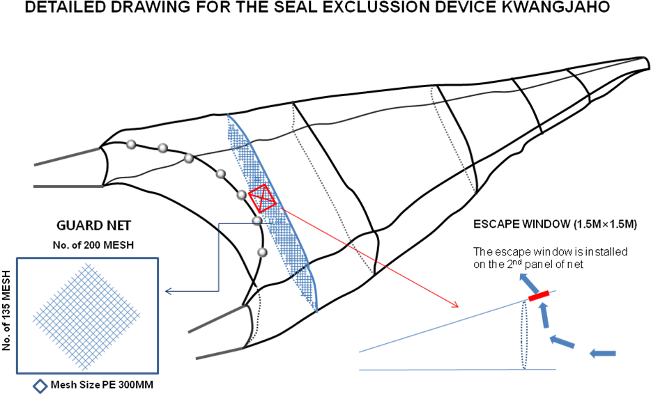
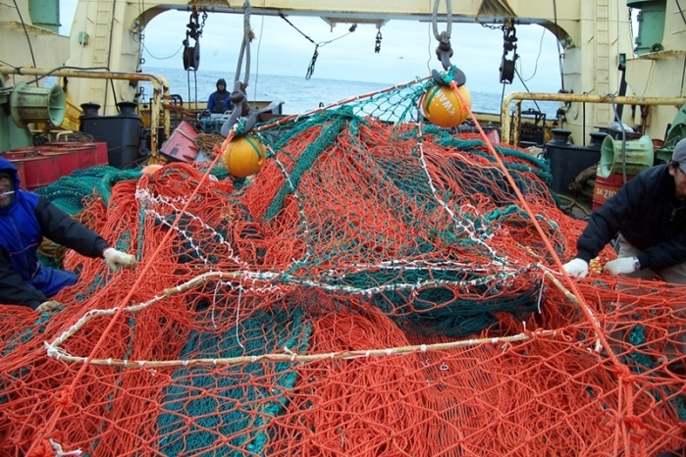 | 