ANNEX 21-03/A

NOTIFICATION OF INTENT TO PARTICIPATE IN A FISHERY
FOR EUPHAUSIA SUPERBA

General information

Member: Republic of Korea

Fishing season: 2020/2021

Name of vessel: KWANGJAHO
Expected level of catch (tonnes of green weight): 20,000tonnes
Vessel’s daily processing capacity (tonnes of green weight) 240tonnes

Intended fishing subareas and divisions

This conservation measure applies to notifications of intentions to fish for krill in Subareas 48.1, 48.2, 48.3 and 48.4 and Divisions 58.4.1 and 58.4.2. Intentions to fish for krill in other subareas and divisions must be notified under Conservation Measure 21-02.

Subarea/division | Tick the appropriate boxes
48.1 | √
48.2 | √
48.3 | □
48.4 | □
58.4.1 | □
58.4.2 | □

Fishing technique: Tick the appropriate boxes
√Conventional trawl
- Continuous fishing system
- Pumping to clear codend
- Other method: Please specify ______________________________

Product types and methods for direct estimation of green weight of krill caught

 | Product type |  |  | Method for direct estimation of green weight of krill caught,
 |  |  |  | where relevant (refer to Annex 21-03/B)¹
 | Whole frozen |  |  | Holding Tank Volume
 | Boiled |  |  | Holding Tank Volume
 | Meal |  |  | Holding Tank Volume
 | Oil
 | Other product, please specify
 |  | ¹ If the method is not listed in Annex 21-03/B, then please describe in detail _____________

 | Net configuration
Net measurements |  | Net 1 | Net 2 | Other net(s)
Net-mouth opening height (m) |  | 30 | 30
Net-mouth opening width (m) |  | 72 | 72
Total net length (m) including codend,  Measured along the centerline of the net |  | 167.6 | 167.6
Codend-mouth opening height (m) |  | 1.5 | 1.5
Codend-mouth opening width (m) |  | 3 | 3
Codend length (m) |  | 32 | 32
Codend mesh size (mm;stretched mesh) |  | Inner 15  Outer 100 | Inner 15  Outer 100

Net diagram(s): KWANG JA HO

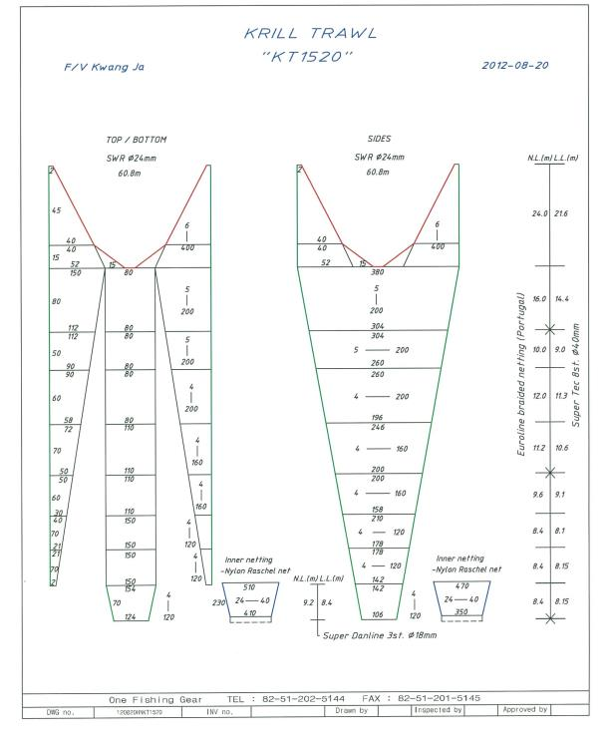

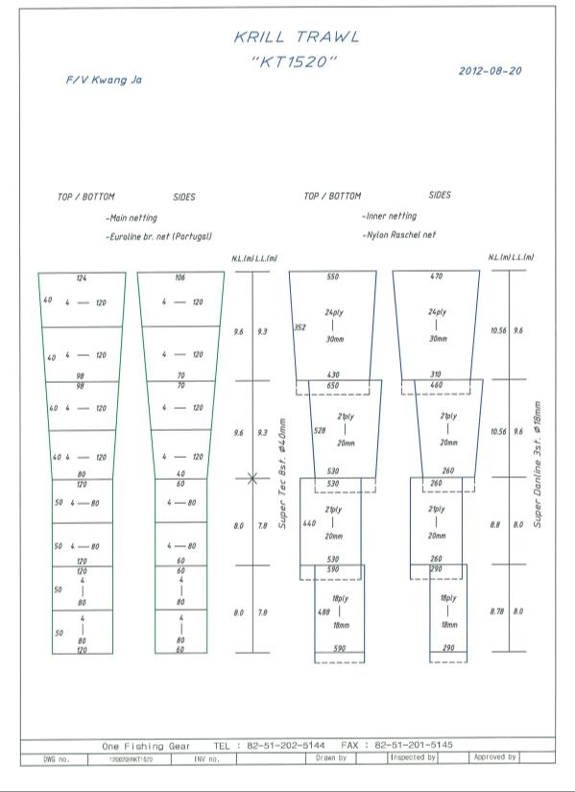

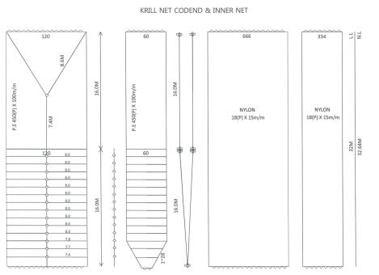

For each net used, or any change in net configuration, refer to the relevant net diagram in the CCAMLR fishing gear library if available (www.ccamlr.org/node/74407), or submit a detailed diagram and description to the forthcoming meeting of WG-EMM. Net diagrams must include:

- Length and width of each trawl panel (in sufficient detail to allow calculation of the angle of each panel with respect to water flow.)
- Mesh size (inside measurement of stretched mesh based on the procedure in Conservation Measure 22-01), shape (e.g. diamond shape) and material (e.g. polypropylene).
- Mesh construction (e.g. knotted, fused).
- Details of streamers used inside the trawl (design, location on panels, indicate ‘nil’ if streamers are not in use); streamers prevent krill fouling the mesh or escaping.

Marine mammal exclusion device

Device diagram(s): KWANG JA HO

For each type of device used, or any change in device configuration, refer to the relevant diagram in the CCAMLR fishing gear library if available (www.ccamlr.org/node/74407), or submit a detailed diagram and description to the forthcoming meeting of WG-EMM.

- Uses of marine mammal protect net: We use this device to prevent sea lions from capturing. Sea lions can escape through the square hole whose size is 1.5m and located on the top of the net, when they enter into the net by accident. This device is very effective, but sea lions were sometimes captured only in the South Georgia.
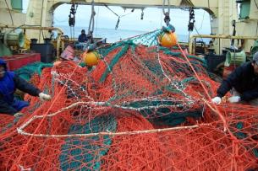 | 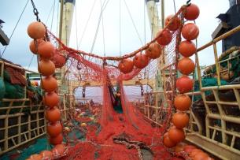

Collection of acoustic data

Provide information on the echosounders and sonars used by the vessel.

Type (e.g. echosounder, sonar) | Echosounder
Manufacturer | Kongsberg Maritime AS
Model | SIMRADES - 70
Transducer frequencies (kHz) | 38㎑, 120㎑

Collection of acoustic data (detailed description): __________
Outline steps which will be taken to collect acoustic data to provide information on the distribution and abundance of Euphausiasuperba and other pelagic species such as myctophiids and salps (SC-CAMLR-XXX, paragraph 2.10)

We submitted an acoustic data of whole Krill fishing period which was gathered by Simrad to Korean National Research &Development Institute.

