Net diagram(s): KWANG JA HO

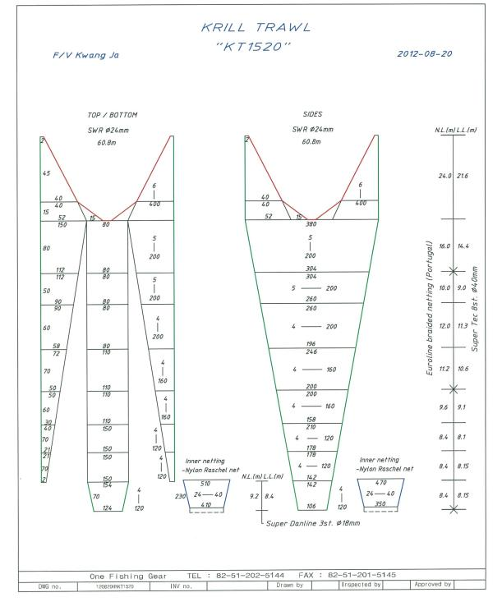

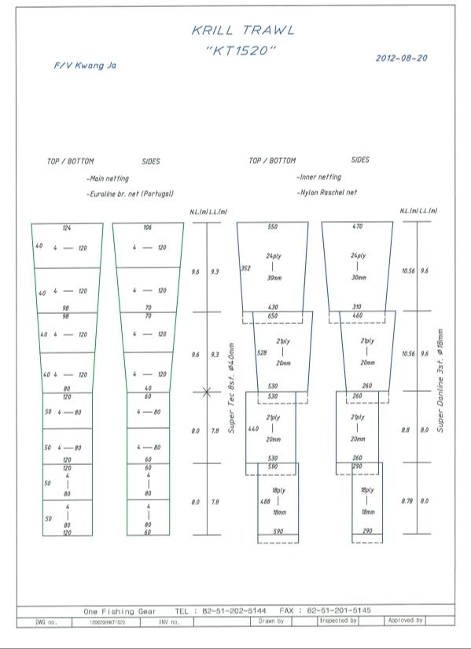

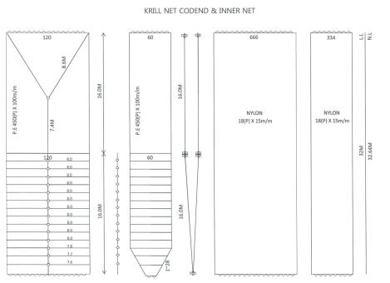

For each net used, or any change in net configuration, refer to the relevant net diagram in the CCAMLR fishing gear library if available (www.ccamlr.org/node/74407), or submit a detailed diagram and description to the forthcoming meeting of WG-EMM. Net diagrams must include:

- Length and width of each trawl panel (in sufficient detail to allow calculation of the angle of each panel with respect to water flow.)
- Mesh size (inside measurement of stretched mesh based on the procedure in Conservation Measure 22-01), shape (e.g. diamond shape) and material (e.g. polypropylene).
- Mesh construction (e.g. knotted, fused).
- Details of streamers used inside the trawl (design, location on panels, indicate ‘nil’ if streamers are not in use); streamers prevent krill fouling the mesh or escaping.

Marine mammal exclusion device

Device diagram(s): KWANG JA HO

For each type of device used, or any change in device configuration, refer to the relevant diagram in the CCAMLR fishing gear library if available (www.ccamlr.org/node/74407), or submit a detailed diagram and description to the forthcoming meeting of WG-EMM.

- Uses of marine mammal protect net: We use this device to prevent sea lions from capturing. Sea lions can escape through the square hole whose size is 1.5m and located on the top of the net, when they enter into the net by accident. This device is very effective, but sea lions were sometimes captured only in the South Georgia.
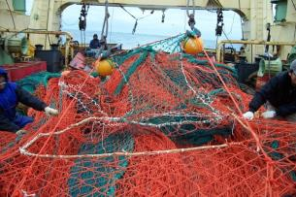 | 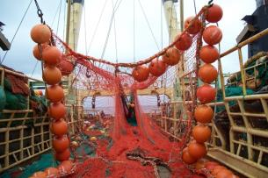

Collection of acoustic data

Provide information on the echosounders and sonars used by the vessel.

Type (e.g. echosounder, sonar) | Echosounder
Manufacturer | Kongsberg Maritime AS
Model | SIMRADES - 70
Transducer frequencies (kHz) | 38㎑, 120㎑

Collection of acoustic data (detailed description): __________
Outline steps which will be taken to collect acoustic data to provide information on the distribution and abundance of Euphausiasuperba and other pelagic species such as myctophiids and salps (SC-CAMLR-XXX, paragraph 2.10)

We submitted an acoustic data of whole Krill fishing period which was gathered by Simrad to Korean National Research &Development Institute.

