**Fishing gear Diagram details**

**Fishing gear configuration**

***Figure 1. Fishing gear diagram & detail.***

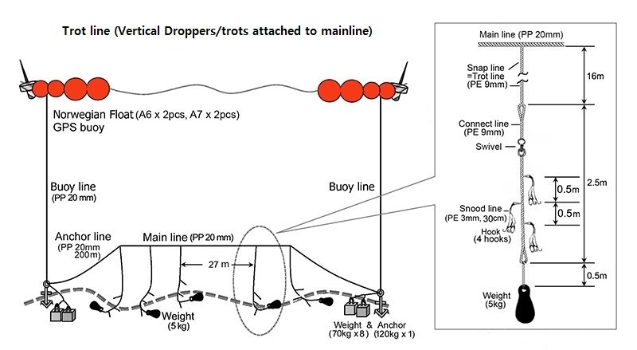



***Figure 2. The parts of connect line***

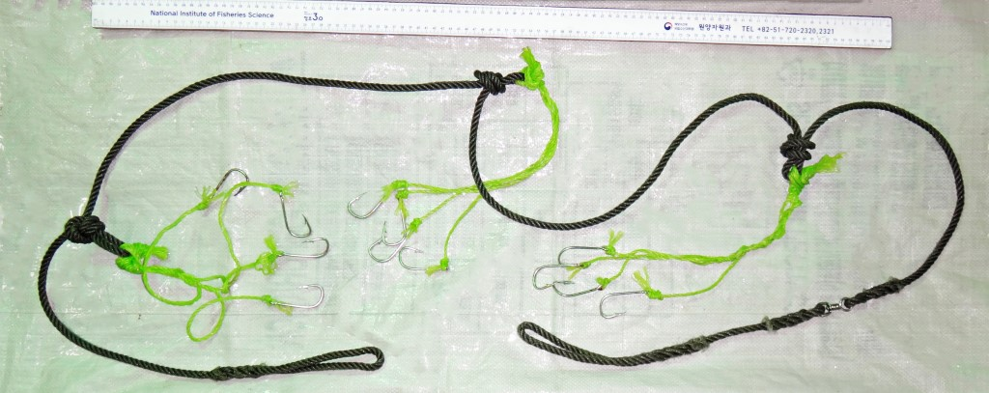

***Figure 3. Detail of Hook***

|  |  |  |
| --- | --- | --- |
| Part of Hook | Specifications | hooks |
| Front Length | 32mm |
| Total Length | 65mm |
| Gape | 22mm |
| Diameter | Ø3.2mm |
| N.Weight | 7.5g |