Figure 8. Marine mammal exclusion device “Komandor”

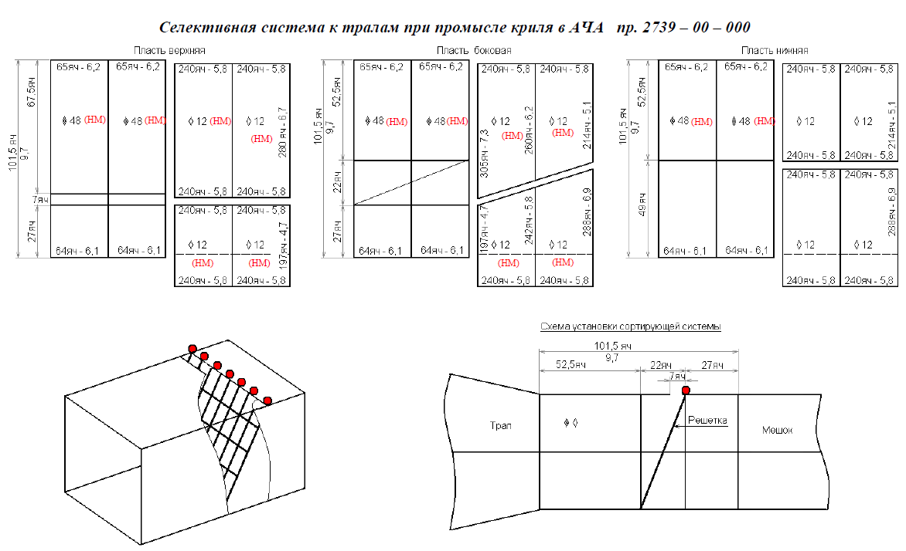
Opening size: 672 x 6144 mm.
Grid mesh size before codend: 100 mm.

