**Net configuration   
(Complete a table for each net )**

**Net 1**

|  |  |  |
| --- | --- | --- |
|  | Net measurements | |
| Net opening (mouth) |  | |
| - Maximum vertical opening (m) | 25 | |
| - Maximum horizontal opening (m) | 30 | |
| - Net circumference at mouth1 (m) | 231 | |
| Mouth area (m2) | 3,268 | |
| Panel average mesh size3 (mm) | Outer2 | Inner2 |
| 1st panel | 240 |  |
| 2nd panel | 200 |  |
| 3rd panel | 160 |  |
| 4th panel | 160 |  |
| 5th panel | 150 | 40 |
| 6th panel | 140 | 40 |
| 7th panel | 140 | 30 |
| 8th panel | 140 | 25 |
| 9th panel | 140 | 20 |
| Final panel (Codend) | 120 | 15 |

1 Expected in operational conditions.

2 Size of outer mesh and inner mesh where a liner is used.

3 Inside measurement of stretched mesh based on the procedure in Conservation Measure 22-01.

Net diagram(s): SEJONG

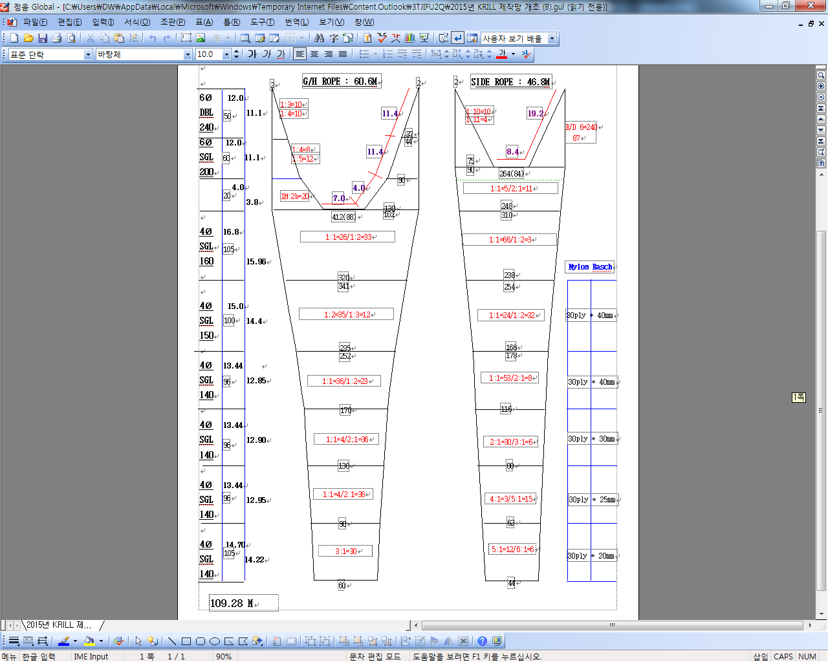

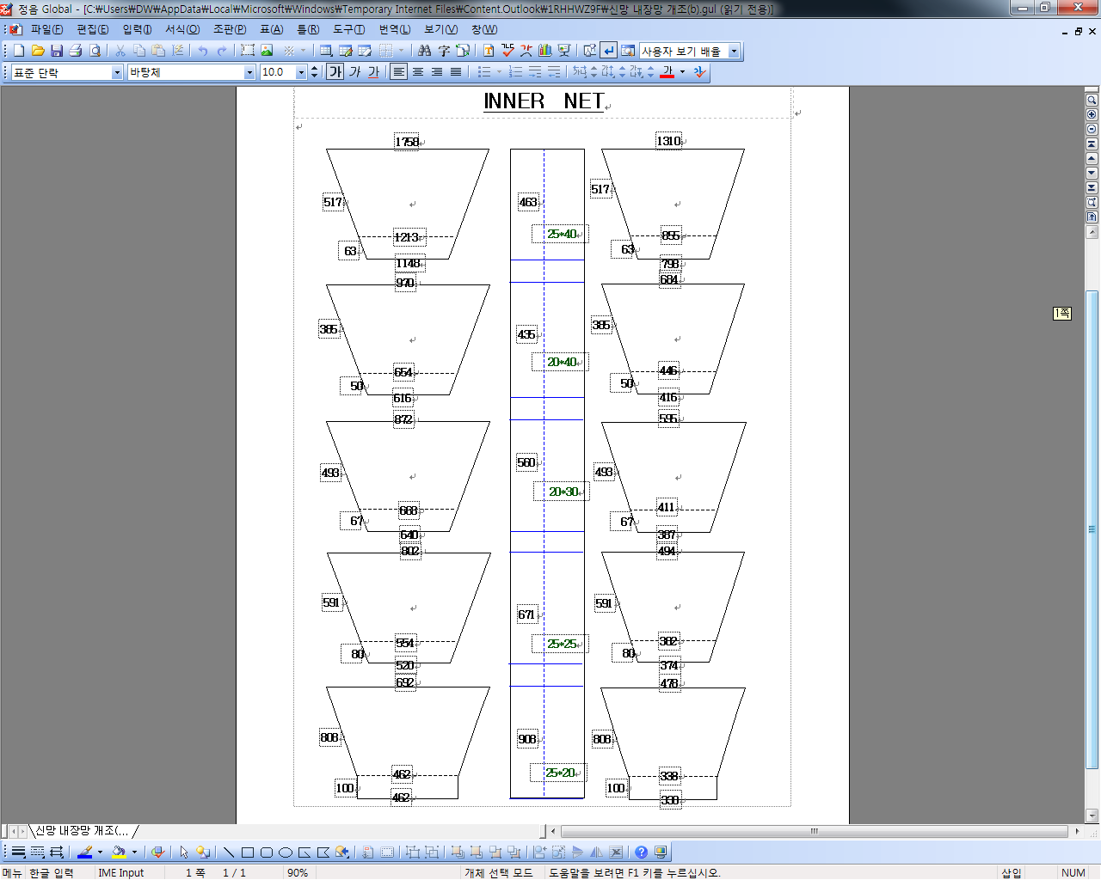

*For each net used, or any change in net configuration, refer to the relevant net diagram in the CCAMLR fishing*

*gear library if available (www.ccamlr.org/node/74407), or submit a detailed diagram and description to the*

*forthcoming meeting of WG-EMM. Net diagrams must include:*

*1. Length and width of each trawl panel (in sufficient detail to allow calculation of the angle of each panel*

*with respect to water flow.)*

*2. Mesh size (inside measurement of stretched mesh based on the procedure in Conservation Measure 22-01),*

*shape (e.g. diamond shape) and material (e.g. polypropylene).*

*3. Mesh construction (e.g. knotted, fused).*

*4. Details of streamers used inside the trawl (design, location on panels, indicate ‘nil’ if streamers are not*

*in use); streamers prevent krill fouling the mesh or escaping.*

**Net 2**

|  |  |  |
| --- | --- | --- |
|  | Net measurements | |
| Net opening (mouth) |  | |
| - Maximum vertical opening (m) | 25.0 | |
| - Maximum horizontal opening (m) | 27.6 | |
| - Net circumference at mouth1 (m) | 225.28 | |
| Mouth area (m2) | 3,145 | |
| Panel average mesh size3 (mm) | Outer2 | Inner2 |
| 1st panel | 240 |  |
| 2nd panel | 240 |  |
| 3rd panel | 240 |  |
| 4th panel | 160 |  |
| 5th panel | 160 |  |
| 6th panel | 160 | 50 |
| 7th panel | 140` | 40 |
| 8th panel | 140 | 30 |
| 9th panel | 140 | 25 |
| 10th panel | 130 | 20 |
| Final panel (Codend) | 120 | 15 |

1 Expected in operational conditions.

2 Size of outer mesh and inner mesh where a liner is used.

3 Inside measurement of stretched mesh based on the procedure in Conservation Measure 22-01

Net diagram(s): SEJONG

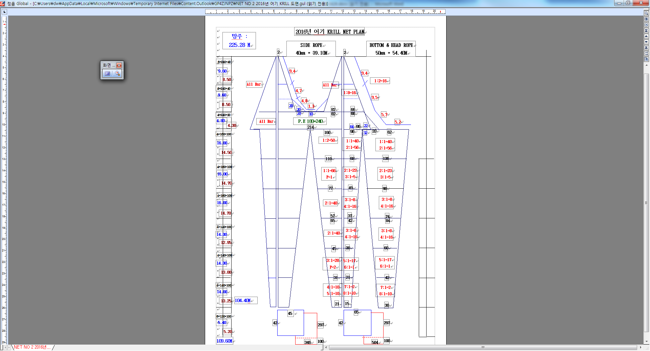



*For each net used, or any change in net configuration, refer to the relevant net diagram in the CCAMLR fishing*

*gear library if available (www.ccamlr.org/node/74407), or submit a detailed diagram and description to the*

*forthcoming meeting of WG-EMM. Net diagrams must include:*

*1. Length and width of each trawl panel (in sufficient detail to allow calculation of the angle of each panel*

*with respect to water flow.)*

*2. Mesh size (inside measurement of stretched mesh based on the procedure in Conservation Measure 22-01),*

*shape (e.g. diamond shape) and material (e.g. polypropylene).*

*3. Mesh construction (e.g. knotted, fused).*

*4. Details of streamers used inside the trawl (design, location on panels, indicate ‘nil’ if streamers are not*

*in use); streamers prevent krill fouling the mesh or escaping.*