The scheme and description of the fishing gear (trot-line).
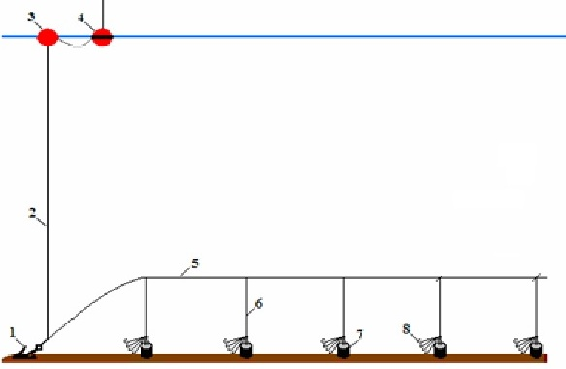

Figure 1. Scheme of the bottom longline (trot-line) aboard of the FV CALIPSO: 1 - anchor; 2 - buoy rope; 3 - buoy; 4 - radio buoy; 5 - mainline; 6 – dropline; 7 - concrete cylindrical weights; 8 - bunch of 10 hooking snoods.

