Instruction manual for the collection of
fishing vessel-based acoustic data
Version 2.0

Preface
This manual is to be used by the person(s) who are responsible for the collection of raw acoustic data on board krill fishing vessels operating in the CAMLR Convention Area. The specific instruments covered by this manual are limited to Simrad ES60, Simrad ES70, Simrad EK60, Simrad ES80 and Simrad EK80 echosounders.
The data collected according to this manual, whether during specially designed surveys along nominated transits or during fishing operations (including searching for suitable fishing aggregations and steaming to another fishing area), are potentially very valuable and may be used to provide qualitative and quantifiable information on the distribution and relative abundance of Antarctic krill (Euphausia superba). This information is fundamental to CCAMLR’s approach to management.
The manual consists of:
Chapter 1: A brief overview of what data should be collected, where and when they should be collected and finally how they should be collected.
Chapter 2: Data logging instructions.
Chapter 3: Validation of instrument performance.
Chapter 4: An overview of metadata to accompany data submissions to the Secretariat.
For further details, please contact your national technical coordinator or Scientific Committee Representative or contact the CCAMLR Secretariat (ccamlr@ccamlr.org).
Thank you for taking the time to record these important data.
Chapter 1
A brief overview of recommendations for data collection
What data should be collected: Raw acoustic data and supporting metadata describing the acoustic data, the acoustic instruments and cruise should be collected. The actual acoustic data needs to have the correct metadata (the data that describe the data) in order to be useable.
Where data should be collected: Acoustic data, together with supporting metadata, should be collected in all of the areas for which the vessel has been licenced to fish for krill. The acoustic data collected along the nominated transects (highlighted in bold in Table 1 and Figure 1), as well as in the areas in which fishing actually occurs, are a high priority.
When data should be collected: Acoustic data collection should begin as the vessel enters the Convention Area and be continued until the vessel leaves. Collecting data throughout the entire fishing trip is a prerequisite for building a picture of temporal variability in krill abundance and distribution. In particular, given the importance of the nominated transects in building patterns of temporal variability, repeating these nominated transects as often as possible during the cruise is recommended.
How data should be collected: Raw acoustic data should be logged to a hard drive. The echosounder should be configured using the key settings detailed in Table 2.
Table 1: Waypoints (dd mm.00) of the acoustic transects that are part of existing krill acoustic surveys in Subareas 48.1, 48.2 and 48.3 with the nominated transects highlighted in bold. Maps showing the location of the nominated transects are in Figure 1.
Subarea | Transect | Waypoint 1 |  | Waypoint 2
 |  | Longitude | Latitude | Longitude | Latitude
48.1 | T1 | 63°00.00'W | 62°15.00'S | 62°00.00'W | 62°45.00'S
 | T2 | 62°30.00'W | 62°00.00'S | 61°30.00'W | 62°30.00'S
 | T3 | 62°00.00'W | 61°45.00'S | 61°00.00'W | 62°15.00'S
 | T4 | 61°30.00'W | 61°30.00'S | 60°00.00'W | 62°15.00'S
 | T5 | 61°00.00'W | 61°15.00'S | 59°30.00'W | 62°00.00'S
 | T6 | 60°30.00'W | 61°00.00'S | 59°00.00'W | 61°45.00'S
 | T7 | 58°30.00'W | 60°00.00'S | 58°30.00'W | 61°30.00'S
 | T8 | 57°30.00'W | 60°00.00'S | 57°30.00'W | 61°45.00'S
 | T9 | 57°00.00'W | 60°00.00'S | 57°00.00'W | 61°45.00'S
 | T10 | 56°30.00'W | 60°00.00'S | 56°30.00'W | 61°45.00'S
 | T11 | 55°45.00'W | 60°00.00'S | 55°45.00'W | 61°45.00'S
 | T12 | 55°00.00'W | 60°00.00'S | 55°00.00'W | 61°03.00'S
 | T13 | 54°30.00'W | 60°00.00'S | 54°30.00'W | 61°45.00'S
 | T14 | 54°00.00'W | 60°00.00'S | 54°00.00'W | 61°03.00'S
 | T15 | 61°30.00'W | 63°00.00'S | 60°30.00'W | 63°30.00'S
 | T16 | 60°30.00'W | 63°00.00'S | 59°30.00'W | 63°30.00'S
 | T17 | 60°00.00'W | 62°45.00'S | 59°00.00'W | 63°15.00'S
 | T18 | 59°30.00'W | 62°30.00'S | 58°30.00'W | 63°00.00'S
 | T19 | 58°30.00'W | 62°30.00'S | 57°30.00'W | 63°00.00'S
(continued)

Table 1 (continued)
Subarea | Transect | Waypoint 1 |  | Waypoint 2
 |  | Longitude | Latitude | Longitude | Latitude
 | T20 | 58°00.00'W | 62°15.00'S | 57°00.00'W | 62°45.00'S
 | T21 | 57°24.00'W | 62°00.00'S | 56°30.00'W | 62°30.00'S
 | T22 | 56°00.00'W | 62°00.00'S | 56°00.00'W | 62°45.00'S
 | T23 | 55°00.00'W | 61°12.00'S | 55°00.00'W | 63°00.00'S
 | T24 | 54°00.00'W | 61°18.00'S | 54°00.00'W | 62°45.00'S
48.2 | T1 | 48°30.00'W | 59°40.20'S | 48°30.00'W | 62°00.00'S
 | T2 | 47°30.00'W | 59°40.20'S | 47°30.00'W | 62°00.00'S
 | T3 | 46°30.00'W | 59°40.20'S | 46°30.00'W | 62°00.00'S*
 | T4 | 45°45.00'W | 59°40.20'S | 45°45.00'W | 60°28.80'S
 | T5 | 45°00.00'W | 59°40.20'S | 45°00.00'W | 60°36.60'S
 | T6 | 44°00.00'W | 59°40.20'S | 44°00.00'W | 62°00.00'S
 | T7 | 45°45.00'W | 60°42.00'S | 45°45.00'W | 62°00.00'S
 | T8 | 45°00.00'W | 60°58.80'S | 45°00.00'W | 62°00.00'S
48.3 | T1 | 39°36.14'W | 53°20.83'S | 39°23.51'W | 54°03.32'S
 | T2 | 39°18.25'W | 53°18.94'S | 39°05.34'W | 54°01.40'S
 | T3 | 39°02.29'W | 53°17.22'S | 38°49.14'W | 53°59.64'S
 | T4 | 38°45.05'W | 53°15.31'S | 38°31.61'W | 53°57.70'S
 | T5 | 38°26.94'W | 53°13.25'S | 38°13.22'W | 53°55.61'S
 | T6 | 38°08.42'W | 53°11.11'S | 37°54.40'W | 53°53.42'S
 | T7 | 37°57.86'W | 53°09.85'S | 37°43.67'W | 53°52.15'S
 | T8 | 37°49.93'W | 53°08.90'S | 37°35.62'W | 53°51.19'S
 | T9 | 36°15.62'W | 54°05.73'S | 35°15.19'W | 53°41.49'S
 | T10 | 36°10.50'W | 54°10.35'S | 35°09.80'W | 53°46.26'S
 | T11 | 36°04.15'W | 54°15.94'S | 35°03.05'W | 53°51.92'S
 | T12 | 35°57.60'W | 54°21.02'S | 34°57.42'W | 53°56.79'S
 | T13 | 35°54.68'W | 54°24.11'S | 34°53.74'W | 53°59.99'S
 | T14 | 35°48.65'W | 54°29.60'S | 34°47.35'W | 54°05.35'S
 | T15 | 35°43.98'W | 54°33.43'S | 34°42.54'W | 54°09.38'S
 | T16 | 35°38.65'W | 54°38.34'S | 34°36.98'W | 54°14.02'S
 | T17 | 35°33.94'W | 54°42.22'S | 34°32.50'W | 54°18.15'S
 | T18 | 35°29.00'W | 54°46.67'S | 34°26.85'W | 54°22.33'S
* Only the northern section (from 59°40.20'S to 60°28.80'S) is a nominated transect.

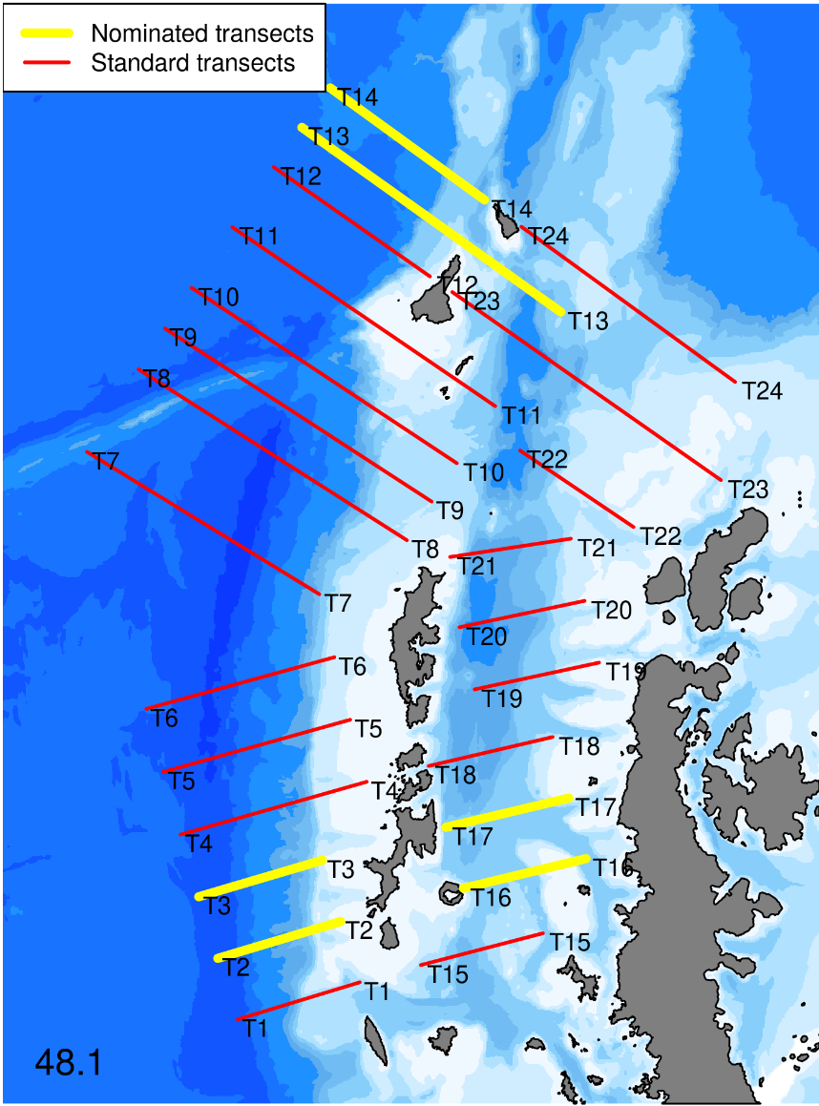
(a)
Figure 1: Location of nominated transects (thick yellow lines) and existing research transects for the collection of acoustic data in: (a) Subarea 48.1.
(continued)

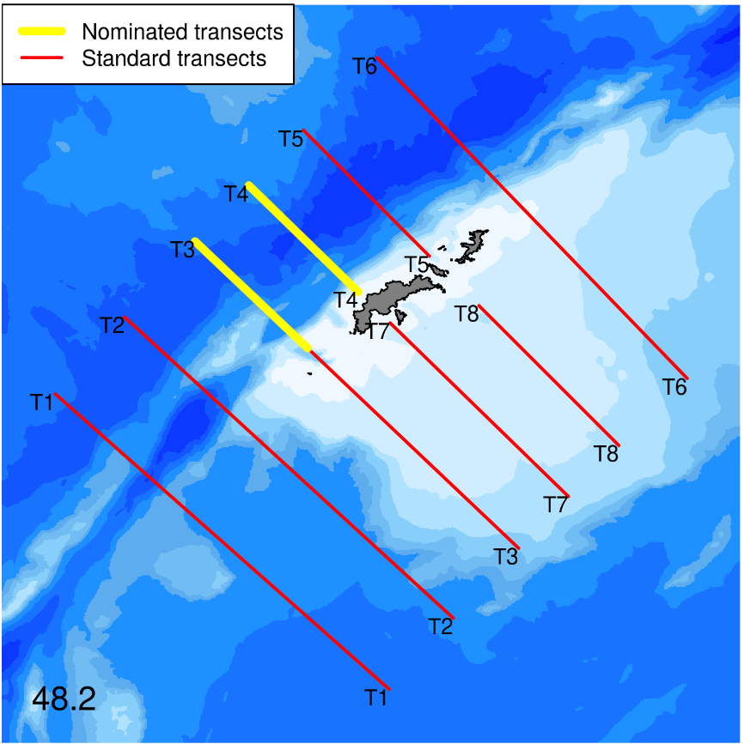
(b)
(c)
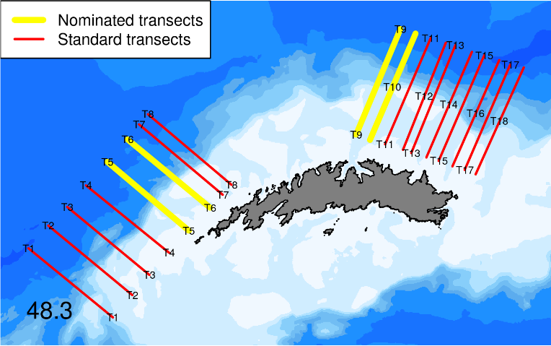
Figure 1 (continued): Location of nominated transects (thick yellow lines) and existing research transects for the collection of acoustic data in: (b) Subarea 48.2 and (c) Subarea 48.3.

Chapter 2
Data logging instructions

2.1. System requirements

Vessels are encouraged to regularly update the data acquisition software.

2.1.1 Echosounder
These instructions apply to Simrad ES60, Simrad ES70, Simrad EK60, Simrad ES80 or Simrad EK80 echosounders. A global positioning system (GPS) (with data output) should be connected to the echosounder. Please refer to the instruction manual of your echosounder to properly configure it according to the settings specified in this chapter.

2.1.2 Data logging device
An external hard drive with a minimum data storage capacity of 2 Tb. The actual volume of data stored depends on the number of frequencies used and the duration of the time in the Convention Area. The data should be stored as Power/Angle samples (ES80 and EK80). The file name should ideally have a unique vessel identifier (e.g. International Maritime Organization (IMO) number) and the instrument type (e.g. EK80) as prefix.

2.2 Instrument parameter settings
2.2.1 The instrument parameters should be set according to Table 2 and should not be changed, except the display range.
Table 2: Instrument setting for data collection.
Parameter | Unit | Setting
Frequency | kHz: | 38 | 70 | 120 | 200
Power¹ | W | 2000 | 700 | 250 | 110
Pulse type² |  | CW | CW | CW | CW
Pulse duration | Microsecond | 1024 | 1024 | 1024 | 1024
Ping interval | Second | 2 | 2 | 2 | 2
Data collection range (min.–max.) | M | 0–1100 | 0–1100 | 0–1100 | 0–1100
Bottom detection range (min.–max.) | M | 5–1100 | 5–1100 | 5–1100 | 5–1100
Display range (min.–max.) | M | 0–1100 | 0–1100 | 0–1100 | 0–1100
¹ Based on Korneliussen et al., 2008.
² Only for EK80 and ES80.

2.3 Operational instructions
• Please ensure your echosounder is operating in Coordinated Universal Time (UTC).
• Please ensure you log the acoustic data.
• The file size for storing acoustic data should be set to 100 MB.
• Where possible, other echosounders (except navigational echosounders) should be turned off to avoid unwanted interference.
• Please record the instrument and calibration attributes listed in Chapter 4 before data collection.
• When collecting data along transects:
- pass through the waypoints of the transects in Table 1 in as straight a line as you can undertake. Transects can be undertaken in either direction (e.g. from N to S or vice versa)
- maintain a constant vessel speed, ideally at 10 knots, that allows low noise data collection
- please record the transect attributes listed in Chapter 4 at the beginning or end of each transect.
Chapter 3
Validation of instrument performance

3.1 External assessment of echosounder performance

3.1.1 Standard sphere calibration
If possible, carry out a standard sphere calibration utilising the techniques described in Foote et al. (1987) and ICES (2015). Locations where regular calibrations have been carried out previously are given in Table 3.
Table 3: Positions (dd mm.00) of regularly used calibration sites in Subareas 48.1, 48.2 and 48.3.
Subarea | Calibration site | Position
 |  | Longitude | Latitude
48.1 | Admiralty Bay | 58°26.58'W | 62°08.10'S
48.2 | Scotia Bay | 44°40.86'W | 60°44.88'S
48.3 | Stromness Bay | 36°40.02'W | 54°09.30'S

3.1.2 Seabed reflection calibration
CCAMLR is currently investigating the use of seabed reflection as another way of externally assessing echosounder performance. A protocol for such assessments will be added to this part of the document once it becomes available.

3.2 Internal assessments of echosounder performance on board of vessels
Internal validation procedures to monitor basic system performance are being developed. Vessels running EK80 or ES80 systems are encouraged to perform built-in self-test equipment (BITE – accessed through the diagnostics dialog box) diagnostics and provide the result by filling in Table 4 or providing a screenshot of the test (Figure 2).

Table 4: BITE diagnostics table.
Transducer serial number
Transducer frequency (kHz)
Channel 1: | Impedence |  | Ohm | Phase |  | ૦
Channel 2: | Impedence |  | Ohm | Phase |  | ૦
Channel 3: | Impedence |  | Ohm | Phase |  | ૦
Channel 4: | Impedence |  | Ohm | Phase |  | ૦

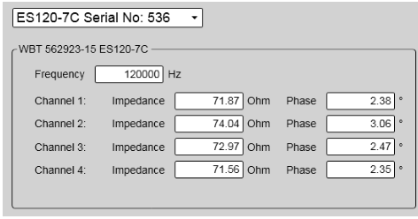
Figure 2: Example of impedance screenshot from a 120 kHz split-beam transducer using the BITE functionality of ES80 software.

Chapter 4
Data reporting and submission
Metadata contain important information that is an essential element of the data logged and should be delivered with the data collected.
Please record the data in Tables 5 and 6 prior to data collection. When data have been collected along nominated transects as listed in Table 1 and shown in Figure 1, please also record the relevant metadata in Table 7.
Please contact your national technical coordinator or Scientific Committee Representative regarding the submission of data to the Secretariat.
Table 5: Cruise metadata required to accompany acoustic data submissions to the Secretariat.
Parameter | Definition
Vessel name | The name of the vessel
Vessel IMO | The IMO number of the vessel
Cruise start date | The date the vessel left port
Cruise end date | The date the vessel returned to port

Table 6: Instrument and calibration attributes recommended to accompany acoustic data submissions to the Secretariat (adapted from SC-CAMLR-41, Annex 5, Table 2).
Parameter | Definition
Operating frequency (kHz) | Frequency of the transceiver/transducer combination in kHz. Some systems, such as broadband and multibeam, will have a range of frequencies. If so, specify the minimum, maximum and centre frequency
Transducer location | Location of installed transducer. Refer to ICES SISP 4-TG-AcMeta Appendix B.2 for a list of standard transducer locations
Transducer manufacturer | Transducer manufacturer
Transducer model | Transducer model
Transducer depth (m) | Mean depth in metres of transducer face beneath the water surface
Transducer orientation | Direction perpendicular to the face of the transducer. A simple description for a ship mounted sounder would be ‘downward-looking’, a mooring could be ‘upward-looking’. If required, ICES SISP 4-TG-AcMeta Appendix C provides a comprehensive description of transducer orientation conventions
Transducer equivalent beam angle (dB) | Manufacturer-specified transducer equivalent beam angle in dB, expressed as 10log10(Ψ), where Ψ has units of steradians
Transducer beam angle major (degrees) | Major beam opening in degrees, also referred to as ‘athwartship angle’. See ICES SISP 4-TG-AcMeta Appendix D for description of beam geometry conventions
Transducer beam angle minor (degrees) | Minor beam opening in degrees, also referred to as ‘alongship angle’. See ICES SISP 4-TG-AcMeta Appendix D for description of beam geometry conventions
Transceiver manufacturer | Transceiver manufacturer
Transceiver model | Transceiver model
Transceiver serial | Transceiver serial number
(continued)

Table 6 (continued)
Parameter | Definition
Transceiver firmware version | Transceiver firmware version
Calibration date | Date and time of calibration
Calibration method | Describe the method used to acquire calibration data (see ICES SISP 4-TG-AcMeta Appendix B.4, Standard lists)
Calibration processing method | Describe method of processing that was used to generate calibration offsets
Calibration accuracy estimate | Estimate of calibration accuracy. Include a description and units so that it is clear what this estimate means (e.g. estimate might be expressed in dB or as a percentage)
Calibration location | Name of the site where the calibration was carried out. See also Table 3
Acquisition software name | Name of software that controls the echosounder and its data logging
Acquisition software version | Version of software that controls the echosounder and its data logging

Table 7: Transect attributes recommended to accompany acoustic data submissions to the Secretariat (adapted from ICES SISP 4-TG-AcMeta standard and WG-ASAM-2021/15, Table 1).
Parameter | Definition
Subarea | The subarea in which the transect was conducted. For example, 48.1, 48.2 or 48.3
Transect number | The number of the transect as defined in Table 1
Start datetime (UTC) | Start date and time in UTC of the transect formatted following ISO 8601. For example, 18:00 UTC on 24 October 2008 would be represented as 2008-10-24T18:00:00
End datetime (UTC) | End date and time in UTC of the transect formatted following ISO 8601. For example, 18:00 UTC on 24 October 2008 would be represented as 2008-10-24T18:00:00
Start latitude | The latitude of the start of the transect expressed in decimal degrees
Start longitude | The longitude of the start of the transect expressed in decimal degrees
Start heading | The heading at the start of the transect expressed in degrees
Start course | The course at the start of the transect expressed in degrees
Start depth (m) | The bottom depth in meters at the start of the transect
Start speed (kn) | The speed of the vessel in knots at the start of the transect
Start wind direction | The wind direction at the start of the transect expressed in degrees
Start wind speed (kn) | The wind speed in knots at the start of the transect
Start sea state | The state of the sea at the start of the transect using World Meteorological Organization (WMO) Sea State Codes
End latitude | The latitude of the end of the transect expressed in decimal degrees. Positive values are north of the equator, negative values are south of the equator
End longitude | The longitude of the end of the transect expressed in decimal degrees. Positive values are east of the Greenwich Meridian, negative values are west of it
End heading | The heading at the end of the transect expressed in degrees
End course | The course at the end of the transect expressed in degrees
End depth (m) | The bottom depth in meters at the end of the transect
End speed (kn) | The speed of the vessel in knots at the end of the transect
End wind direction | The wind direction at the end of the transect expressed in degrees
End wind speed (kn) | The wind speed in knots at the end of the transect
End sea state | The state of the sea at the end of the transect using WMO Sea State Codes
Transect comments | Free text field for relevant information that might not be captured by the defined attributes

References
Foote, K.G., H.P. Knudsen, G. Vestnes, D.N. MacLennan and E.J. Simmonds. 1987. Calibration of acoustic instruments for fish density estimation: a practical guide. ICES Coop. Res. Rep., 144: 69 pp.
ICES. 2015. Calibration of acoustic instruments. ICES Coop. Res. Rep., 326: 136 pp, doi: https://doi.org/10.17895/ices.pub.5494.
Korneliussen, R.J., N. Diner, E. Ona, L. Berger and P.G. Fernandes. 2008. Proposals for the collection of multifrequency acoustic data. ICES J. Mar. Sci., 65: 982–994.

