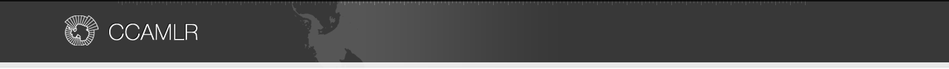

Argos Froyanes
Gear details
Line type | Autoline
Line material | 12 mm thick Polyester/polypropylene mix
Average line length and range
6,708 m (4,500 – 10,800)
Hook type | EZ 14/0 straight shank
Number of hooks per line and spacing² | 4,472 (3,000 – 7,200) at 1.5 m spacing
Snood Length | 0.4m
Weight material and mass | Integrated weight, 50 g/m
Spacing of weights | N/A
Sink rate
0.37m/s
Anchor type and number | One 65/80kg grapnel anchor and one 40/45kg chain at either end.
Floats and spacing | N/A
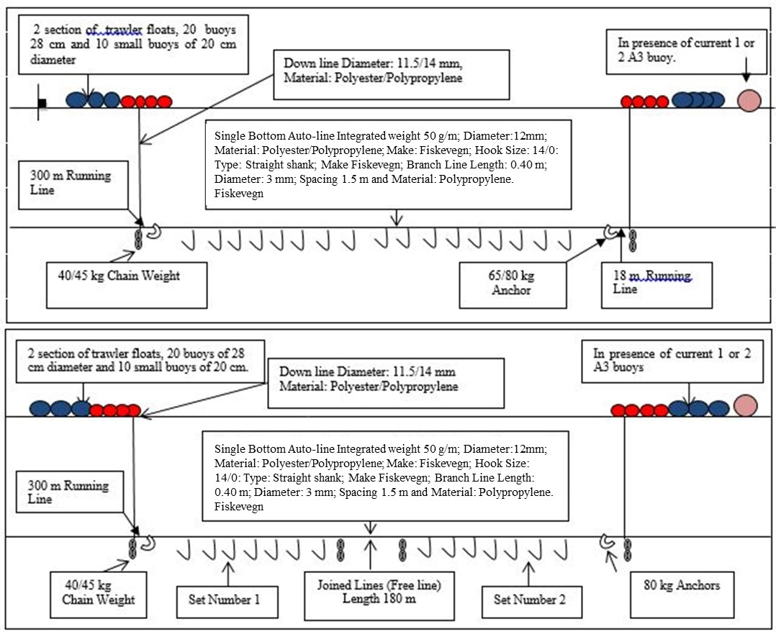
The vessel uses two different gear configurations depending on the topography of the fishing grounds and the ice conditions, single lines and join lines, as illustrated above.

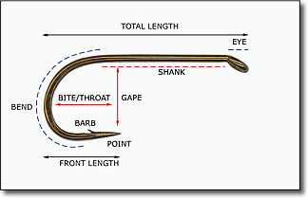
Type | Straight shank
Make | Fiskevegn
Total length |  | 78
Shank (mm) |  | 45
Gape (mm) |  | 16
Throat (mm) |  | 33
Front length (mm) |  | 35
Usual setting position
Line off bottom (m) |  | 0
Hooks off bottom (m) |  | 0

Based on 2018/19 data from Argos Froyanes.
For regular gear, measurement of sink rates is no longer required, data are from 2014/15 season from Argos Froyanes.

