Bottom Longline (Trot Line) Gear Diagram
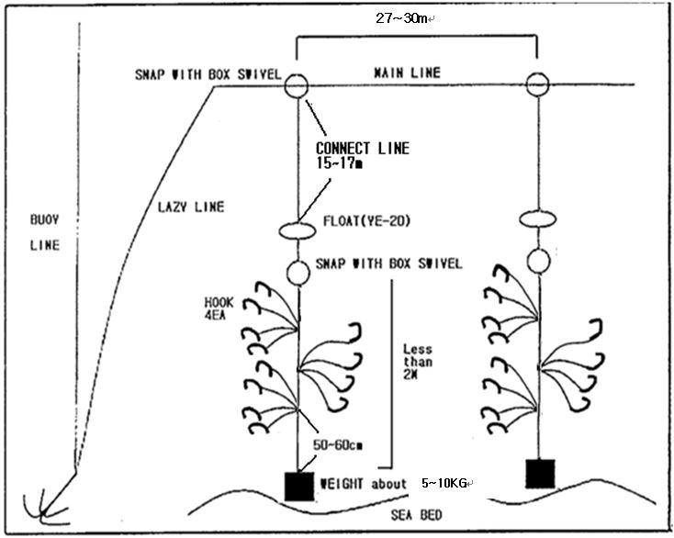
- Trot line fishing gear configuration

As each cluster has 4-5 hooks, each drop line has 3 clusters X 4 hooks = 12 hooks
or each drop line has 3 clusters X 5 hooks = 15 hooks
- List of the Trot Line Fishing Gear Configuration

- The part of connect line
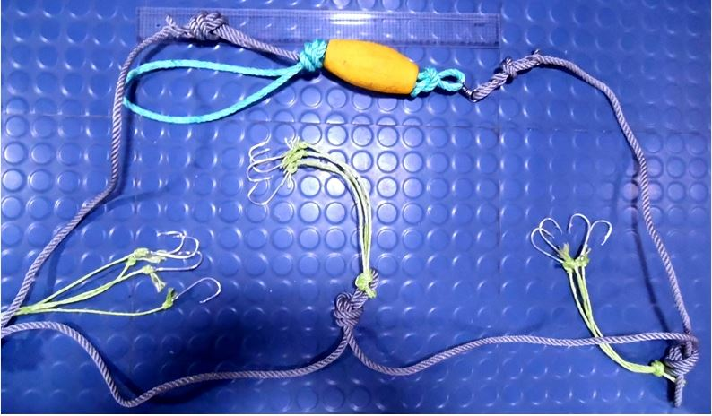

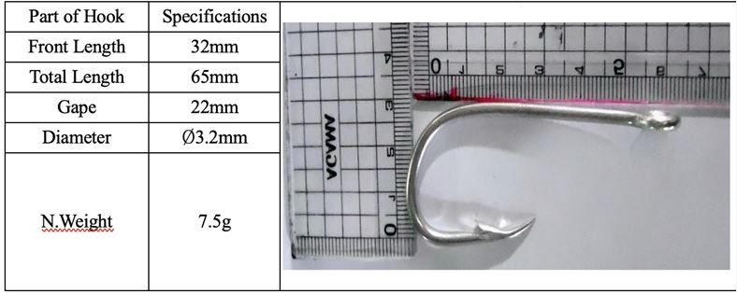
- details of hook

