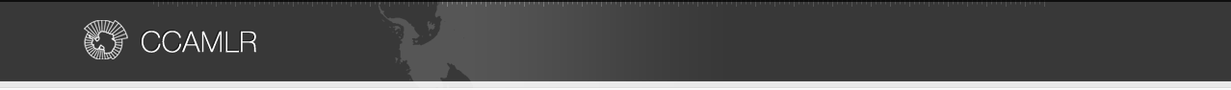
Argos Froyanes
Gear details
Line type | Autoline
Line material | 12 mm thick Polyester/Nylon braided rope
Average line length and range
6,708 m (4,500 – 10,800)
Hook type | 14/0 curved shank
Number of hooks per line and spacing² | 4,472 (3,000 – 7,200) at 1.6 m spacing
Snood Length | 0.4m
Weight material and mass | Integrated weight, 50 g/m
Spacing of weights | N/A
Sink rate
0.37m/s
Anchor type and number | One 65/80kg grapnel anchor and one 40/45kg chain at either end.
Floats and spacing | N/A
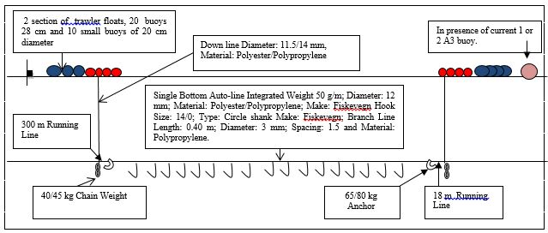
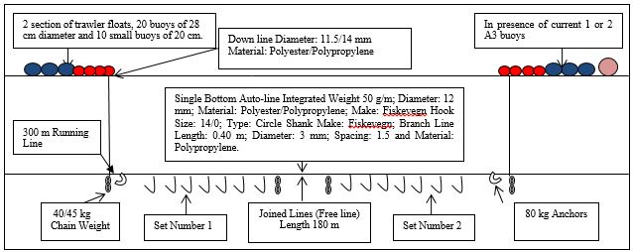
The vessel uses two different gear configurations depending on the topography of the fishing grounds and the ice conditions, single lines and join lines, as illustrated above.

The hook types and dimensions for the vessel are given below.
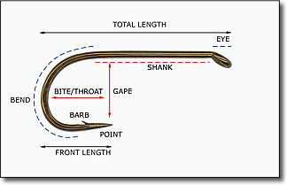
Type | Curved shank
Make | Fiskevegn
Total length |  | 60
Shank (mm) |  | 38
Gape (mm) |  | 25
Throat (mm) |  | 32
Front length (mm) |  | 35
Usual setting position
Line off bottom (m) |  | 0
Hooks off bottom (m) |  | 0

Based on 2015/16 data
For regular gear, measurement of sink rates is no longer required, data are from 2013/15 season.

